TOPDRY Folding Frame – Coathanger Replacement Installation Instructions
Parts List
AD05522 | Coathanger Wire- Smoke | 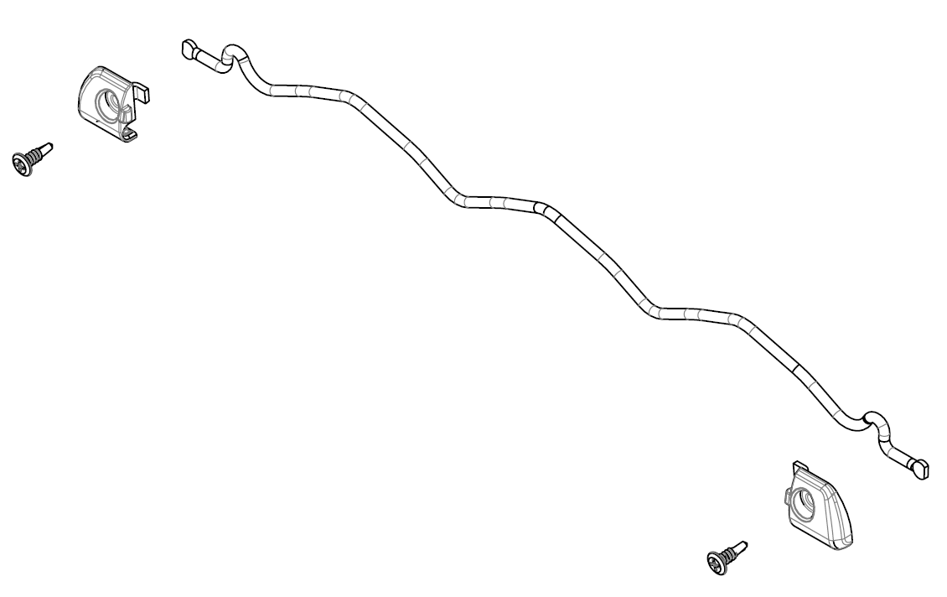
AD05523 | Coathanger Wire - Slate

Replace the Coathanger wire
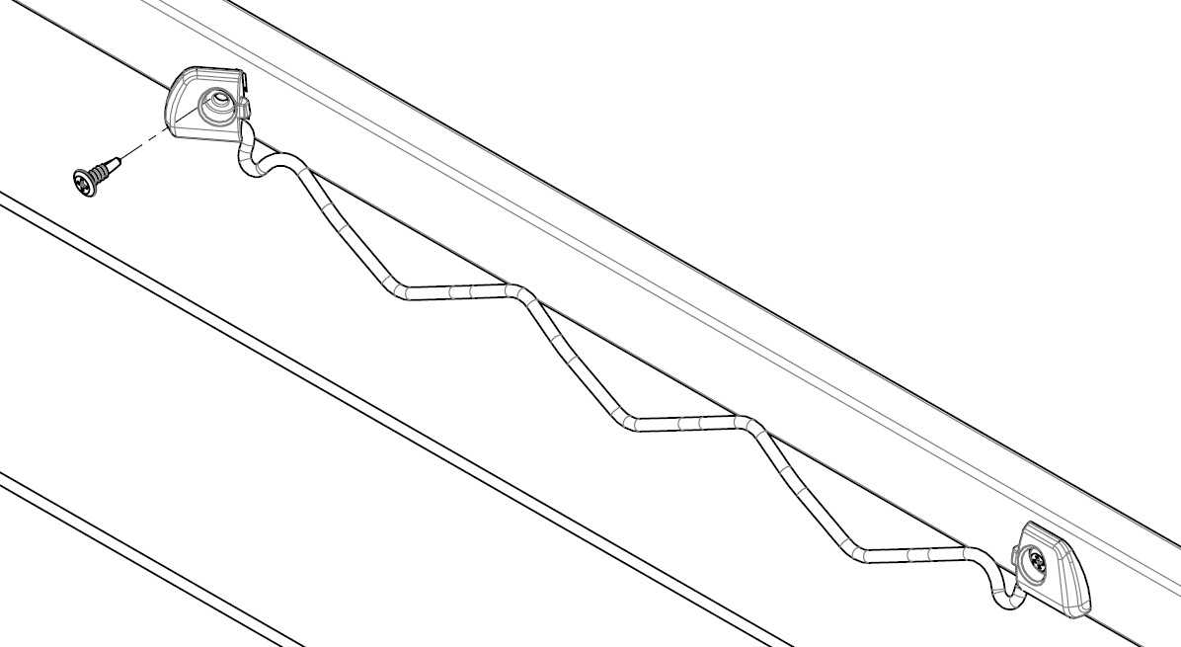
1
3
2
- Fold the Coathanger wire to the down position.
- Remove the screws from both sides using a cross head screw driver
- Tilt the wire holder and move outwards to remove – repeat for both sides
- Repeat process in reverse to fit the new parts.
Sales Force National Pty Ltd (t/a Zenexus), ABN: 60 110 379 587. Phone: 1300 734 714 (AU), 0800 800 040 (NZ). E-mail: customerservice@zenexus.com.au(AU), customerservice@zenexus.co.nz (NZ). Website: www.zenexus.com.au

