Portable Single Burner BBQ
Cast Iron Grill & Hotplate
- Cooking surface 495 mm (W) x 370 mm (D)
- Cast Iron Grill & Hotplate
- Solid steel construction
- Ideal for grilling, roasting, baking & searing
- Side carry handles
- Temperature gauge
- IAPMO gas certiﬁed
- Universal LPG only
- Hose & regulator included
- Dimensions: 710L x 490W x 345H mm
1
Burner
S/Steel
Grill & Dial Burner Hotplate Ignition Material

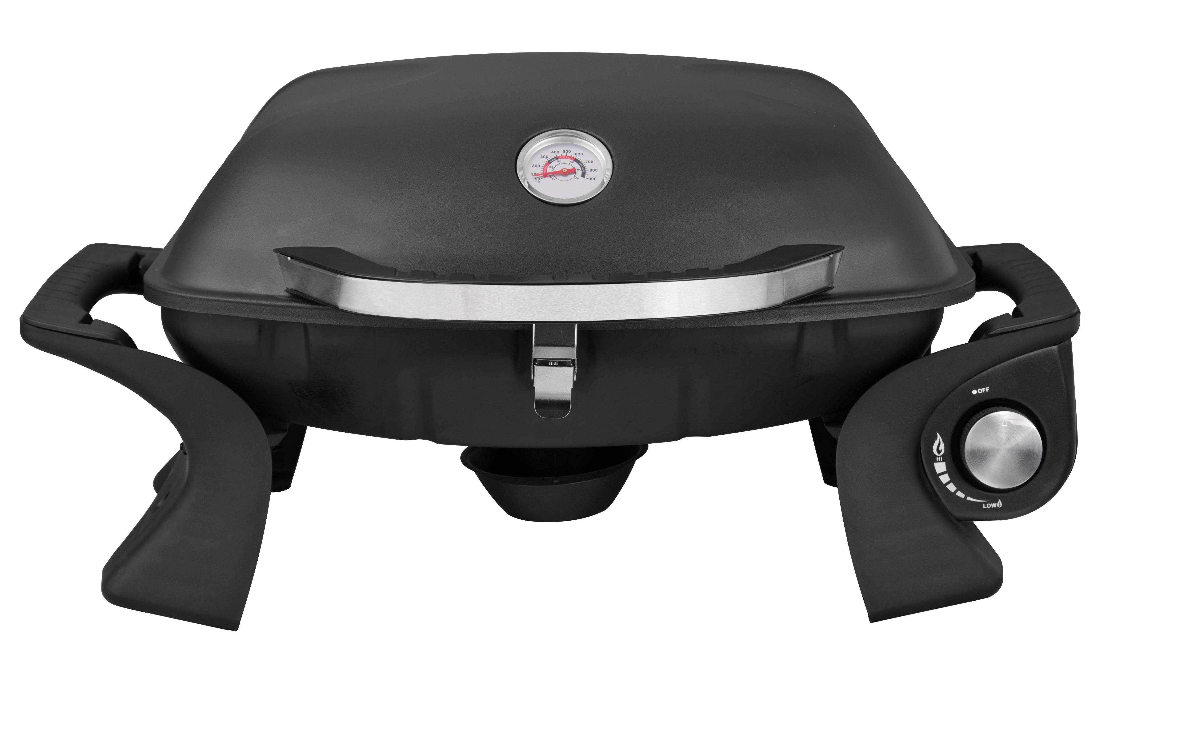

ASSEMBLY le OPERATION INSTRUCTIONS
PORTABLE SINGLE BURNER BBO-

FOR YOUR SAFETY
If you smell gas:
- Shut off gas tothe appliance.
- Extinguish any open flame.
3. If odour continues,immediately ca II your gas supplier.
FOR YOUR SAFETY
,. Do not store or use gasoline or other flammablevapours or liquids inthe vicinity ofthis or any other appliance.
2. A gas cylinder not connected for use shall not be stored inthe vicinity of this or any other appliance.

- For outdoor use only.
- Improper installation,adjustment,alteration, service or maintenance can cause property damage,injury or death.
- Read the installation, operating and maintenance instructions thoroughly before installing or servicingthis equipment.
- Warning:accessible parts may be very hot. Keep young children away.
- Do not move the appliance during use.
- Turn off the gas supply atthe gas cylinder after use.
- Any modification of the appliance may be dangerous and will void the warranty.
- Installer to leave instructions with the consumer and consumer to retain them for future reference.
- Please ensure all packaging and transit protection materials are removed prior to usingthe BBQ.
- Do not replace the grillwith an extra hotplate.You wilIviolate the gas certification as the grill provides the ventilation needed for the BBQto operate safely,it is not designed to be a solid hotplate device.

IMPORTANTI PLEASE READ THESE INSTRUCTIONS CAREFULLY BEFORE USEI

UNIVERSAL LPG CiAS ONLY

SAFETY INSTRUCTIONS
IMPORTANT:READ THE ASSEMBLY INSTRUCTIONS IN THIS BOOKLET BEFORE REMOVI NG
THE CONTENTS OF THIS CARTON

IMPORTANT SAFETY INSTRUCTIONS

This appliance must only be used in an above ground open-air situation with natural ventilation, without stagnant areas,where gas leakage and products of combustion are rapidly dispersed by
wind and natural convection
- This BBQ should not be located under overhead combustible construction and proper clearances must be maintained at all times from combustible construction and/or materials, with MINIMUM clearances as follow:

  - This BBQ is an outdoor appliance only. Under no circumstances should it be use indoors.
  - READ ALL OPERATING INSTRUCTION BEFORE LIGHTING
  - Do not perform any servicing on the BBQ yourself. This includes internal adjustment of the regulator and gas valves. Servicing can only be carried out by authorized technicians.
  - When gas cylinder is replaced or reconnected, check for lea ks.
  - Do not store chemicals or flammable materials near this applianee.
  - Unsupervised children should not be near a BBQ while cookingor during warm up or cool down.
  - People with flammable clothingsuch as nylon etc. shou Id keep well away from the BBQwhen it is operating.
  - Do not leave food unattended on the BBQ.
  - In case of fat fire, turn gas cylinder off.
  - Particular care must be taken when removingoil cup. Hot oil can cause serious injury.
From Sides 915mm From Back 915mm High ,ooomm

  - Turn all gas valves off includinggas cylinder after use.
  - Never leave burner on high for more than 10 minutes unless actually cooking. Ifthe burner makes hissing sound when lit, it may be burning inside. Turn burner off,allow it to cool and try again.
  - Do not allow build up of unburned gas.
  - Oil cup needs to be cleaned regularly to prevent excessive fat or grease build upthat might contribute to a fire.

DO NOT
DO NOT DO NOT

DO NOT DO NOT DO NOT
OPERATE THIS APPLIANCE BEFORE READING THE INSTRUCTION BOOKLET
PLACE ARTICLES ON OR AGAINST THIS APPLIANCE
STORE CHEMICALS OR FLAMMABLE MATERIALS OR SPRAY AEROSOLS NEAR THIS APPLIANCE
OPERATE THIS APPLIANCE INDOORS
ENCLOSE THIS APPLIANCE
LIGHT OR OPERATE WITH THE COVER ON(COVER NOT INCLUDED)

WARNING OTHER CONSIDERATIONS

A strong gas smell or the hissing sound of gas indicates a serious problem with your gas BBQor the gas cylinder. Failure to immediately follow the steps listed below could cause serious bodily injury, death, or property damage.
  - Shut off gas supply to the gas BBQ.
  - Put out any flame with a class B fire extinguisher.
  - Get away from the gas cylinder.
  - Do not try to fix the problem yourself.

If odour continues or you have a fire you cannot extinguish, call your fire department. Do not call near the gas cylinder because your telephone is an electrical device and could create a spark resulting in fire and/or explosion.

NOTE: The normal flow of gas through the regulator and hose assembly can create a humming sound.A low volume of sound is perfectly normal and will not interfere with operation of the BBQ.If humming sound is loud and excessive you may need to purge air from the gas line or reset the regulator excess gas flow device. This purging procedure should be done every time a new gas cylinder is connected to your BBQ.
- Strong winds and low temperatures can affect the heating and performance ofyour gas BBQ so factor in these elements when positioning your BBQ outdoors for cooking.
- Never useyour gas BBQ in a garage, porch, shed, breezeway or any other enclosed area.
- Your gas BBQ is to be used outdoors only, at least 91.5 cm from the back andside of any combustible surface. Your BBQ should not be placed under any surface that will burn.
- Do not obstruct the flow of ventilation air around the gas BBQ housing.This gas BBQ is not intended to be installed in or on recreational vehicles and/or boats.

INSTALLATION COMPLIANCE

This appliance must be installed in accordance to the installation instructions provided by the manufacturer, local gas fitting regulations, municipal building codes, AS5601 I AG 601 gas installation codes and any other relevant statutory regulations

PLACEMENT OF BBQ

PIACEMENTOF BBQ
- Thls product Ts mearrtforoub1oor11Seonlyl Donot store petroloranyInflammablellqulds nearthis product.
- Always placethe s-scylinder beside the BBQwhen notInuse.Somemodels haWlrcomforagas bottle undefncill:hthe bumer-thisisonly tobe used whenthe BBQIsr.oldl

NOTE:
Wrongfulinstallation, adjustments and changes,o, lack of semce and maintenancer.ould cause damageto lndMduals or materfals. It Is thereforeImportant to carefully read theInstructions on how tolnstalL use
and maintain the product beforeas:sembllngthe Item.
The BBQ must be nstalled acamUngto natlonal/local l'l!gUlatlons. Make sure that the gas hose Is not
ANf ENCIOSUIIE INWHICH THEAPPUANCE IS USED
MU5rCOMPLYWITHONEOFTHE fOUWINO:
Anenclosurewtthwallsonallsldes,but at leastone permanentopenlnsat gn:iund le-.,el and noO'lffhead cover.Withina part alenclosurethatincludes an
_,headCIM!rand nomorethantwo walls.Within a
partialenclosurethatincludes anO'lffhead tlM:f and morethantwowalls,thefollowingshallapp

i. atleast 25%ufthemtalwallareaiscomplcb:ly open;and
II. atleast 30'Kofthl!remainingwall area Isopenand unrestricted.

Inthecase ofbalconles.at least 20%ofthetotal ofthe side,backandfront wallareasshallbeand remain openand unrestr cted.

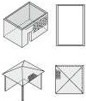
OuldOOt' Jrea ext1 3 ..

"''""""· · . ' \

clenched,and-r in amtad with hot surbces,and thatthe BBQlsInstalledInexact aa.crdancewiththese Instructions. For service, please cnntad authorized personnel.Always ensure that the BBQ Is placed aw.ty ftcm Inflammable matll!rlal when belns used.When IIBhte<I.the BBQ must be kept under survelllance at all times.Keep chlldren at a safe dlstana! ftcm the BBQ; hluchinghot surfaces couldauseburns.The BBQmust be kept cleanto avoid flare-upscaused by remnants af fat Flruresultlns from gnition of grease wlll wld the warranty.Ensure that the gas tyllncler Ts suitable fer your product.
-

Ouldoa area exam!*4

OJ!dcu area e,campe 5
l ,!
·.. ..
m

&I. C)l l'flOfl)
=--
open"°
2!.1'.of ..!llld dfle
l0'.111 WIIJ tffll ternll.fWl(I Wiit
e,00-ISop,. ano
_ffillr.S'J(,nOI _r«,tow -«aie·
--""'
kciw:il :.-e;a rcm!Wlllg w11l
a,ooiSopeoen<1

CiAS CYLINDER SAFETY INFORMATION

GAS TYPE
Note the labeling of appropriate gases listed on your BBQ and ascertain that the gas you have is suitable for your BBQ.Be aware that several different va Ives for gas cylinders exist, and that the regulator must connect appropriately to your gas cylinder.

GAS CONNECTION
- Never try forcing the gas cylinder valve to fit
the gas hose.
- Never make adjustments to low-pressure regulator and hose coupling.
- The gas hose must be inspected for signs of damage/leakage prior to being used. If any of these parts are being replaced, use only parts specified by the manufacturer.
- Do not secure any attachments with tape,or similar materials not meant for gas applications.
- When the gas cylinder is not in use,it must be turned off and disconnectingthe gas hose is advisable.
GAS HOSE REPLACEMENT
In the case of a problem arising with the gas hose, please contact your BBQ supplier for a list of approved replacement parts. The gas hose must comply to Australian gas standards.

GAS CYLINDER STORAGE
Gas cylinder not in use are to be stored outdoors in a well ventilated place, out of reach from children. Make sure that the gas cylinder is placed in an upright position and on an evenly surfaced ground. Additional gas cylinder are not to be stored underneath or in proximity to the BBQ.

SAFETY WHEN LEAKAGE OF GAS IS SUSPECTED
- Turn off the BBQ's gas supply and disconnect the gas hose from the gas cylinder.
- Wipe out any open flames and remove possible ignition sources. If the smell of gas is sustained, please contact your gas supplier or the fire department immediately.
- If the gas cylinder appears to be the source of smell/leakage, place this outdoor with good ventilation and away from possible ignition sources

WARNING
STORE GAS CYLINDER IN A WELLVENTILATED AREA OUT OF REACH OF CHILDREN

LEAK TESTING

Please check for gas leakage the first time you are connecting the BBQ to the gas cylinder, and also each time you are replacing the gas cylinder or disconnecting/reconnecting any fittings. Inspect the hose before each use.

To check for gas leakage, turn on the gas supply at the gas cylinder. Caution - gas will flow from the burner as soon as the cylinder valve is opened. Pour soapy water solution over the cylinder connection. Any gas leakage should result in bubbles appearing immediately. If a gas leakage is detected, tighten the connection and recheck for leaks. If the gas leakage persists, turn off the gas supply and contact your supplier or place of purchase. As an alternative, you may use a gas leak detector, following the manufacturer's instructions, available at all major BBQ retailers. This provides an easier way to check for gas leaks. Do not use the appliance until the gas leak has been rectified.
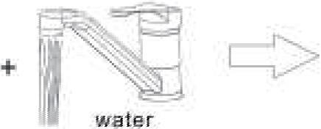 soap
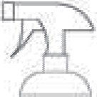,.Add soap and water to spray bottle or soapy water with brush

10N
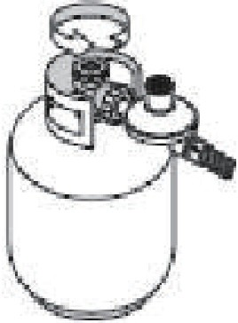

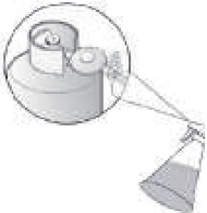2. Turn gas cylinder on

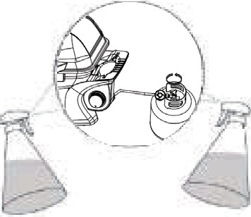DO NOT USE NAKED FLAME FOR LOCATING GAS LEAKS. IF A LEAK PERSISTS, TURN OFF GAS CLYLINDER VALVE AND CALL AN AUTHORISED PERSON

- Spray or apply soapy water on gas connections

- If leak is present, bubbles will appear

LIGHTING
Always visually inspect your grill before lighting. Replace any hoses that are frayed or cracked before lighting your grill. Look for anything that may be blocking spaces for ventilation and remove. After lighting, always check the flame to ensure you have a good flame all along the burner. If not able to light, or the flame is not even along the entire burner, then see the Trouble Shooting section

WARNING
- Read instructions before lighting.
- If ignition does not occur in 5 seconds, turn the burner control(s) off, wait 5 minutes and repeat the lighting procedure

LIGHTING THE MAIN BURNER USING AUTOMATIC IGNITION
- Ensure the burner control knob is in the “Off” position.
- Turn on the LP gas by turning the hand wheel on the cylinder valve.
- Turn the burner control knob marked with an igniter flame to “HI”.
- If the burner does not light within 5 seconds, turn the burner control knob to “Off”. Wait 5 minutes for the gas to clear, and repeat the above procedure. Use the Manual directions if it still will not light.
- When lit, turn the control knob to the desired heat setting.

TURNING OFF YOUR GRILL
- Turn off the gas supply at the LP tank by turning the valve clockwise.
- Turn the burner control knob to the “Off” position.

BBQ MAINTENANCE
Apart from cleaning, your BBQ is a fairly low maintenance appliance. Below are a couple of things worth looking at though. Remember to turn off and disconnect the gas before any maintenance is carried out.

- If your BBQ uses a flexible hose to connect to the gas, check the rubber O-ring on the regulator end of the hose assembly at least once a year. If it appears worn or cracked, have it replaced.
- We recommend having your BBQ checked by an authorized service agent every 5 years.This is to ensure there are no leaks and that all components are still functioning correctly.
- If you use a portable gas cylinder, you will need to have the cylinder serviced or replaced every ten years. The date of the last service should be stamped on the neck of the bottle.
- Keep the outdoor BBQ area clear and free from combustible materials, gasoline, and other flammable vapours or liquids.
- Make sure there is no obstruction surrounding the BBQ, which may block the flow of combustion and ventilation air.
- To maintain the surface of your hotplate, it is recommended to keep the hotplate plate oiled at all times and covered when not in use. A BBQ cover is also recommended to protect your BBQ from all weather conditions.
IMPORTANT INFORMATION
- This product is for outdoor use only.
- Do not use indoors.
- Do not use below ground level.
- Do not store gas cylinders below ground level.
- LP gas is heavier than air so if a leak occurs the gas will collect at a low level and could ignite in the presence of a flame or spark.
- Do not store or use gas cylinders on their side as this could allow liquid gas into the supply pipes with serious consequences.
- Leak test your BBQ before each use. Leak test the hose connections each time you reconnect the gas cylinder.
- Always turn off the gas at the cylinder when not in use.
- Inspect the hose before each use. If there is evidence of excessive abrasion or wear, or the hose is cut it must be replaced prior to the BBQ being put into operation.
- Only use hose supplied from the manufacturer. with 5/8-18 UNF threads.
You must have the correct gas cylinder (4-9 kg) and gas hose for BBQ to operate safely and efficiently. Use of an incorrect gas cylinder or gas hose is dangerous and will void the warranty on this product.

BURNER MAINTENANCE
You should check the burner periodically for any sort of blockage. Use a wire brush to unclog the holes.

To reduce the chance of "FLASH-BACK", the procedure below should be followed at least once a month in late summer or early fall when spiders are most active or when your BBQ has not been used for a period oftime.

- Turn the gas cylinder valve (clockwise) to the full OFF position.
- Detach the gas hose from the gas cylinder.

- Remove burner from the bottom of the BBQ. Use a screwdriver.
- Carefully lift burner up and away from the BBQ.
- Refer to below and perform one of these three cleaning methods.

Bend a stiff wire,(a lightweight coat hanger works well) into a small hook as shown below. Run the hook through the burner tube and inside the burner several times to remove any debris.
Use a bottle brush with a flexible handle. Run the brush through the burner tube and inside the burner several times, removing any debris.
Use a n a ir hose to force air th rough the bu rner tu be. The forced air should pass debris or obstructions through the burner and outthe ports.

- Regardless of which burner cleaning procedure you use, we recommend you also complete the following steps to help prolong burner life.
- Use a wire brush to clean the entire outer surface of each burner until free offood residue or dirt
- Clean clogged ports with wire, such as an open paper clip.

Inspect burner after installation and check to ensure it is securely tightened to the base and injector is centred inside the burner as you found it.

EXPLODED VIEW

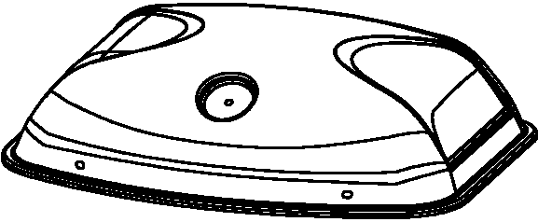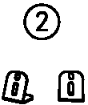

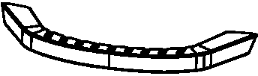®

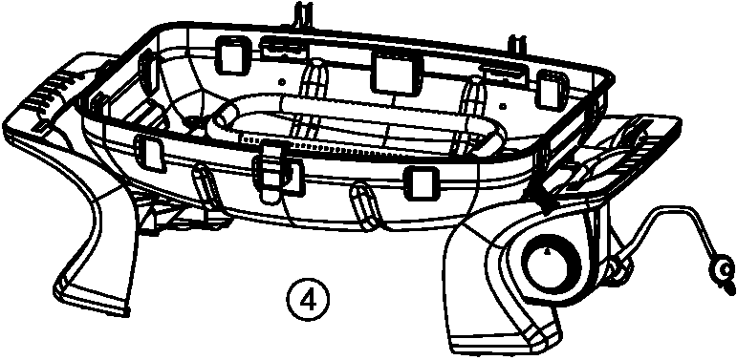

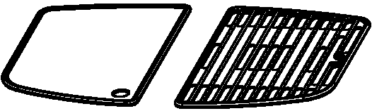®
@

CARTON CONTENTS AND SPARE PARTS

Part list
Parts Number | Discription | Illustration |  |  |  |  |  | Quantity
1 | Lid |  |  |  |  |  |  | 1
2 | Separation blade for the cooking grids |  |  |  |  |  |  | 2
3 | Handle |  |  |  |  |  |  | 1
4 | Firebox |  |  |  |  |  |  | 1
5 | Cast iron cooking plate |  |  |  |  |  |  | 1
6 | Cast iron cooking grill |  |  |  |  |  |  | 1
7 | Thermometer |  |  |  |  |  |  | 1
8 | Grease drip cup |  |  |  |  |  |  | 1

CARTON CONTENTS AND SPARE PARTS

Hardware list
Parts Number | Discription | Illustration | Quantity
A | Hinge bolts |  | 2
B | Clips |  | 2

Step 1
ASSEMBLY INSTRUCTIONS

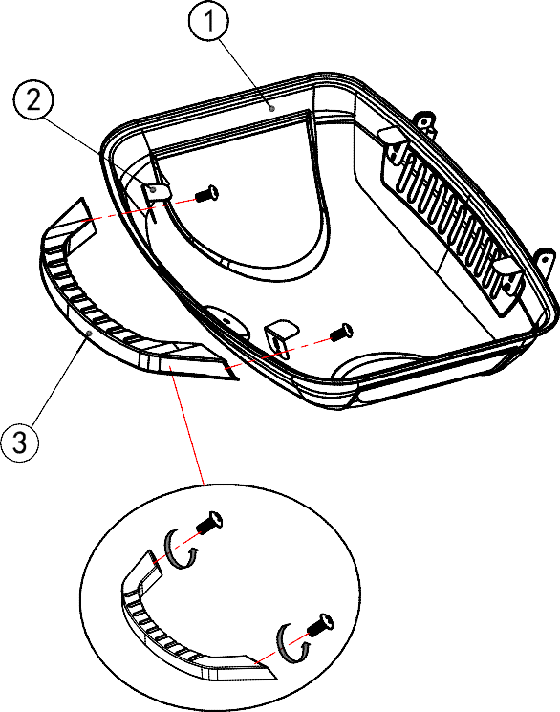2pcs of M4*10mm bolts are supplied in the handle (3). Install the handle (3) to the lid (1) and fix by M4*10mm bolts through the separation blade for the cooking grids (2).

Tools required:
Phillips head screwdriver

Step 2
Fix the left hinges of the lid and the righ t hinges of the lid with hinge bolts (A) and clips (B).

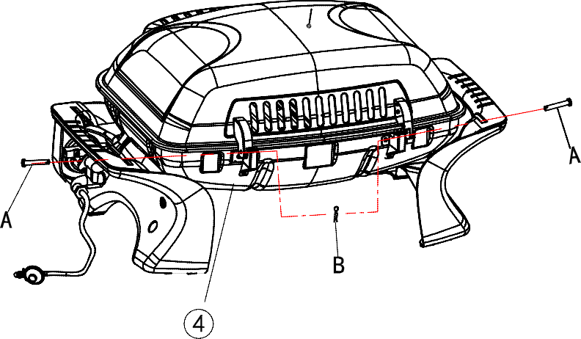

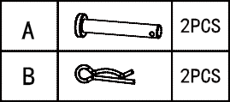

Step 3
ASSEMBLY INSTRUCTIONS

Install the thermometer (7 ) on the lid (1).
Put the cast iron cooking plate (5 ) and the cast iron cooking grill (6) onto the firebox (4 ).

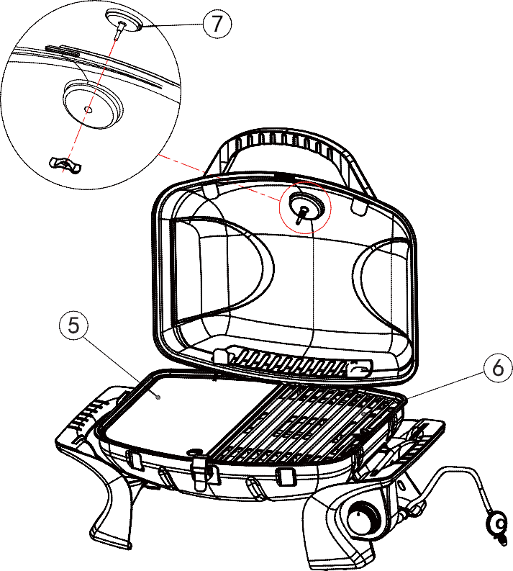
Step 4
Insert the grease drip cup (8) to the bottom of the firebox (4) and the burner BBQ is ready to use now.

Finish

JUMBUCK

Portable Single Burner BBQ

Mayo Hardware
4 Secombe Place Moorebank NSW2170
Phone:1300 360 211
Email: customerservice@mayohardware.com.au

CGP1BHPB

Cast iron cooking grate and plate.
Rotary electronic ignition for easy start every time. Stainless steel heat gauge.
Heavy duty steel construction.
See drawing page ROTARY

Low Pressure Single Stage Regulator & Hose ROTARY
 | 13.5MJ | 2.75kPa | 1.02mm

For Australian Customers
Any claim under this warranty must be made within 12 months of the date of purchase of the product. To make a claim under the warranty contact Mayohardware customerservice@mayohardware.com.au or , take the product (with proof of purchase) to any Bunnings store (see www.bunnings.com.au for store locations)
The warranty covers manufacturer defects in materials, workmanship and finish under normal use.
This warranty is provided in addition to other rights and remedies you may have under law: our goods come with guarantees which cannot be excluded under the Australian Consumer Law. You are entitled to replacement or refund for a major failure and to have the goods repaired or replaced if the goods fail to be of acceptable quality and the failure does not amount to a major failure.

The warranty excludes damage resulting from product misuse or product neglect. The warranty covers domestic use only and does not apply to commercial applications.
For New Zealand Customer
Any claim under this warranty must be made within 12 months of the date of purchase of the product. To make a claim under the warranty contact Mayohardware customerservice@mayohardware.com.au or , take the product (with proof of purchase) to any Bunnings store (see www.bunnings.co.nz for store locations)
The warranty covers manufacturer defects in materials, workmanship and finish under normal use.

This warranty is provided in addition to other rights and remedies you may have under law: our goods come with guarantees which cannot be excluded under the Consumer Guarantees Act 1993 (NZ). You are entitled to
replacement or refund for a major failure and to compensation for other reasonably foreseeable loss or damage. You are also entitled to have the goods repaired or replaced if the goods fail to be of acceptable quality and the failure does not amountto a majorfailure.

The warranty excludes damage resulting from product misuse or product neglect. The warranty covers domestic use only and does not apply to commercial applications.

WHAT IS NOT COVERED IN THE WARRANTY
- Removal or re-installation costs. This warranty does not cover costs for transit, nor in home service.
- Liability will only be accepted for loss or damage during transit if at the time the product was being transported by Bunnings or a Bunnings approved contractor.
- Lack of maintenance, abuse, neglect, misuse, accidental or improper installation of this appliances
- Scratches, dents, corrosion or discoloration caused by heat, abrasive chemicals cleaners
- Corrosions or damage caused by exposure to elements such as insects, weather, hail or grease and fat ﬁres.
- Rusting of hotplate and burner.
- Commercial use of this product.
- Unauthorized repairs or modiﬁcation during warranty period.

RECORD THE FOLLOWING INFORMATION
Attached the copy of the purchase receipt here Date of Purchase ...................................................................
Purchased From......................................................................
Location .................................................................................... Model Name and Number ................................................ Serial Number..........................................................................
Receipt Number.......................................................................

Note:The serial number is located either on the outside of the packing carton or outside or inside the appliance.
FOR TECHNICALASSISTANCE
For Australia customers if you experience any technical issues with your JUMBUCK BBQ, in the ﬁrst instance review the instructions manual or contact Mayo Hatdware at customerservice@mayohard ware.com.au

For New Zealand customers if you experience any technical issues with your JUMBUCK BBQ, in the ﬁrst instance review the instructions manual or contact Mayo Hardware at customerservice@mayohardware.co.nz

FOR SPARE PARTS
Call your local Bunnings warehouse and ask them to order a part for you. You should provide the following information:

Model of BBQ

..............................................................................................
Year of Purchase

..............................................................................................
Name of warranty service company

..............................................................................................
Part that requires replacement (refer to the parts list in the instructions manuaI)

..............................................................................................

