TOPDRY Folding Frame – Corner Replacement Installation Instructions
Parts List
AD05518 | Corner- Smoke | 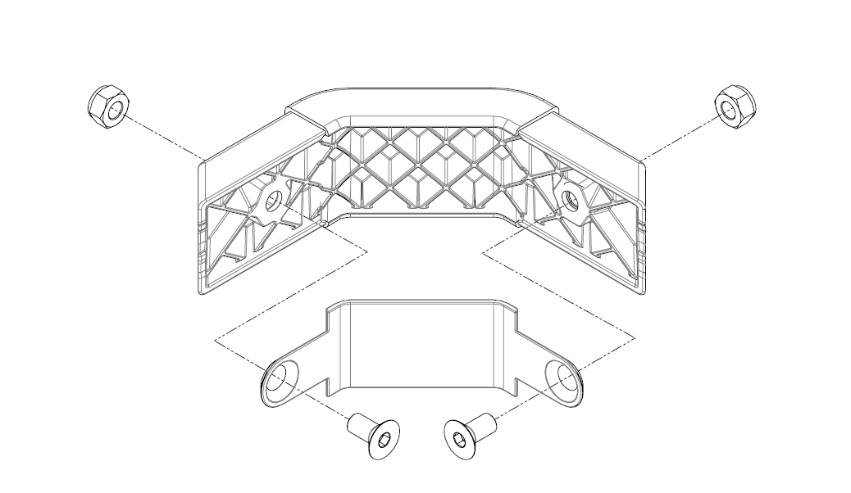
AD05519 | Corner - Slate

Remove existing Corners
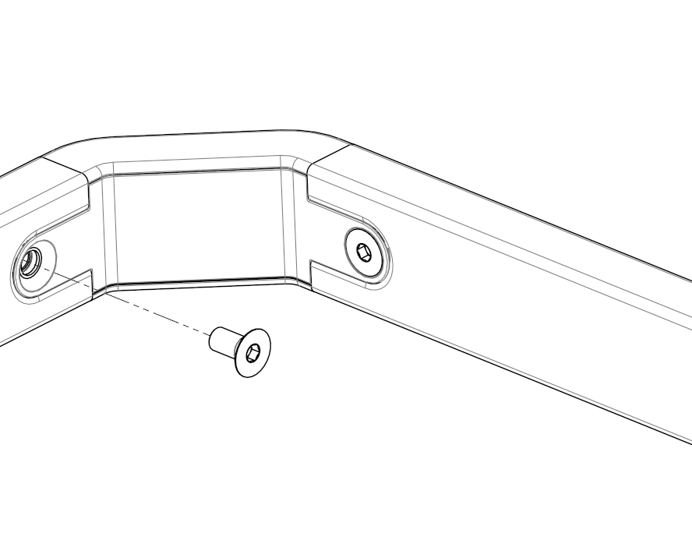 | 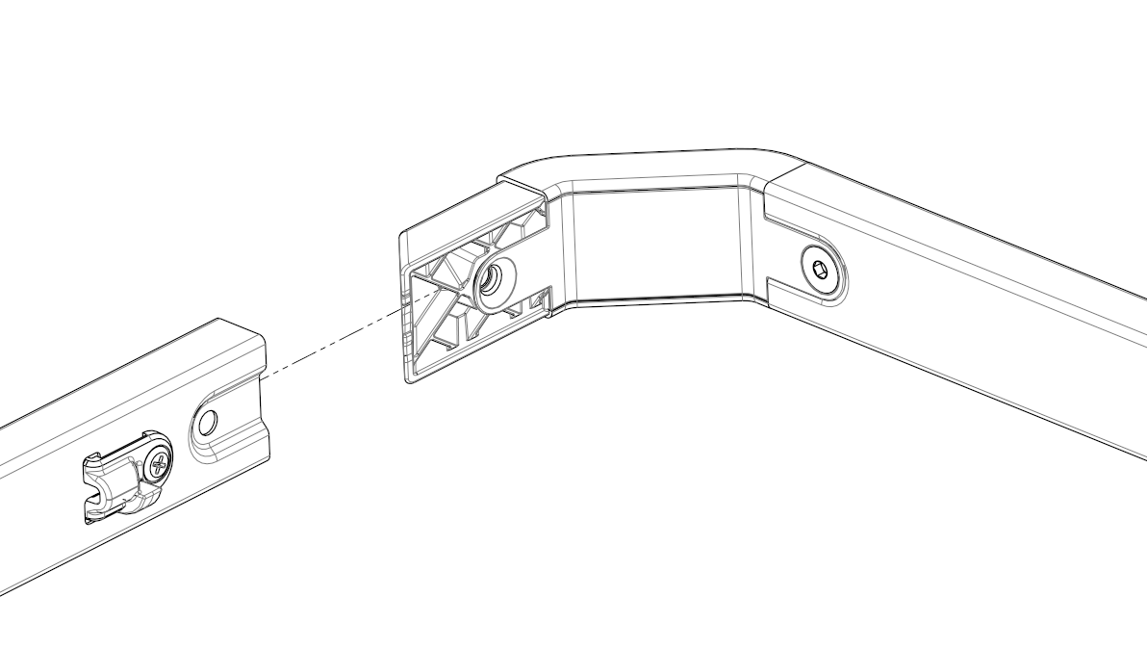
- Remove screw from inside of the Arm. Do this for both sides | - Separate the Spreader with the Corners attached from the Arms

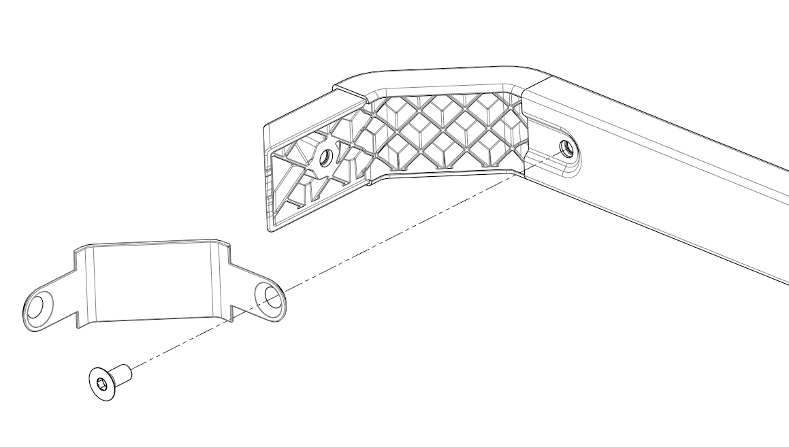 | 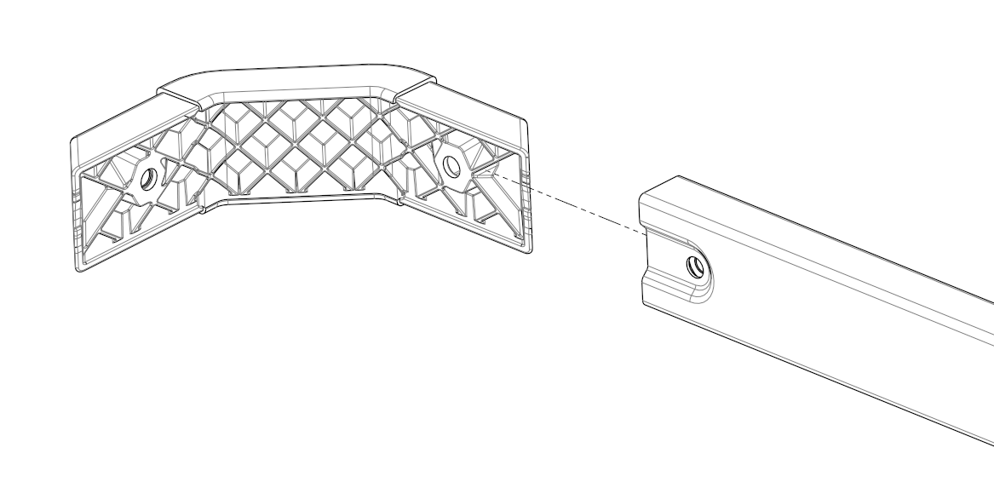
- Remove screw from inside of Spreader. Do this for both sides | - Pull the corners from the Spreader.

Fit new Corner assembly
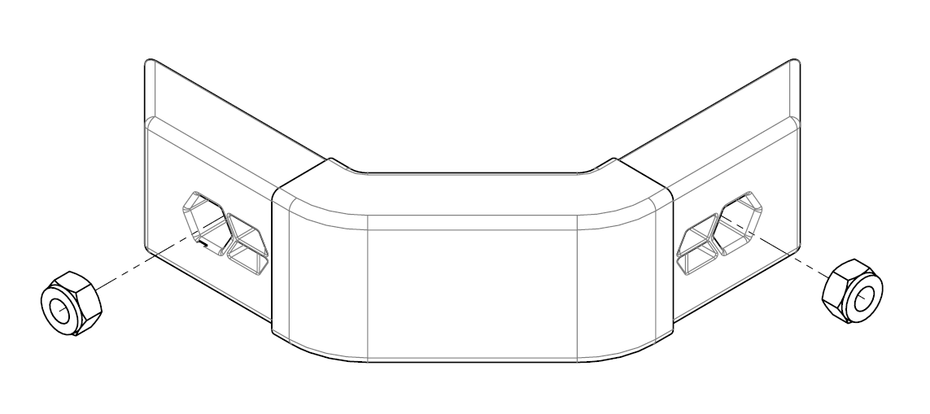
- Check that the M6 Nyloc nuts are pushed into the Corner part. | - Insert the Corners into the Spreader ends, position the Corner Cover and secure with the M6 x 16mm screw.

- Insert the Spreader with the fitted Corners into the arms. | - Secure each Corner to each Arms using a M6x16mm screw
Sales Force National Pty Ltd (t/a Zenexus), ABN: 60 110 379 587. Phone: 1300 734 714 (AU), 0800 800 040 (NZ). E-mail: customerservice@zenexus.com.au(AU), customerservice@zenexus.co.nz (NZ). Website: www.zenexus.com.au

