TOPDRY Retracting – Cross Beam (4 & 6 Line)
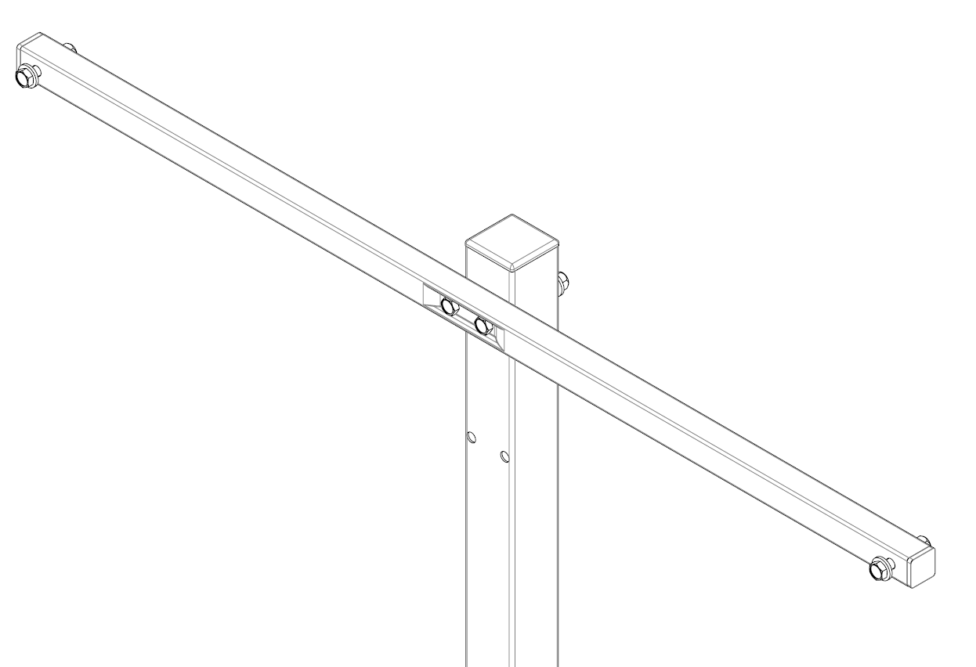
Safety Tips

Only use your clothesline to hang and dry washing.

Remember the clothesline is not a children’s toy.

Don’t use your clothesline if it or the Cross Beam is damaged

Note the following for future reference
Product Name
Date of purchase:
Place of purchase:

Package Contents
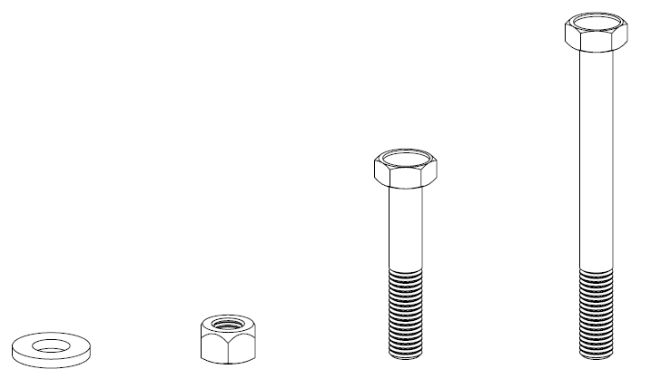
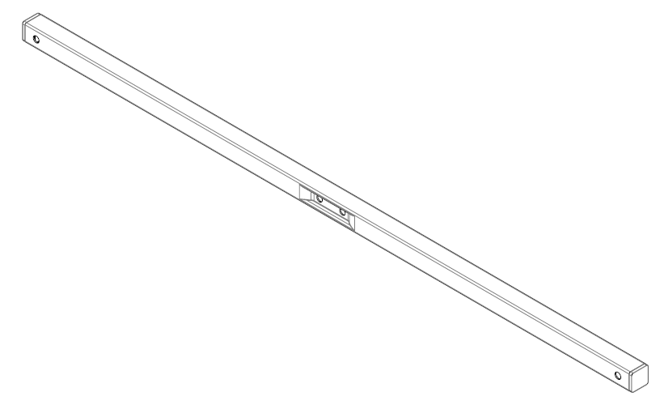
3
2
1
5
4
Item | Description | Quantity |  | Item | Description | Quantity
1 | Cross Beam | 1 |  | 4 | M8 Nut | 4
2 | M8 x 45mm Hex Head Bolt | 2 |  | 5 | M8 Washer | 6
3 | M8 x 80mm Hex Head Bolt | 2
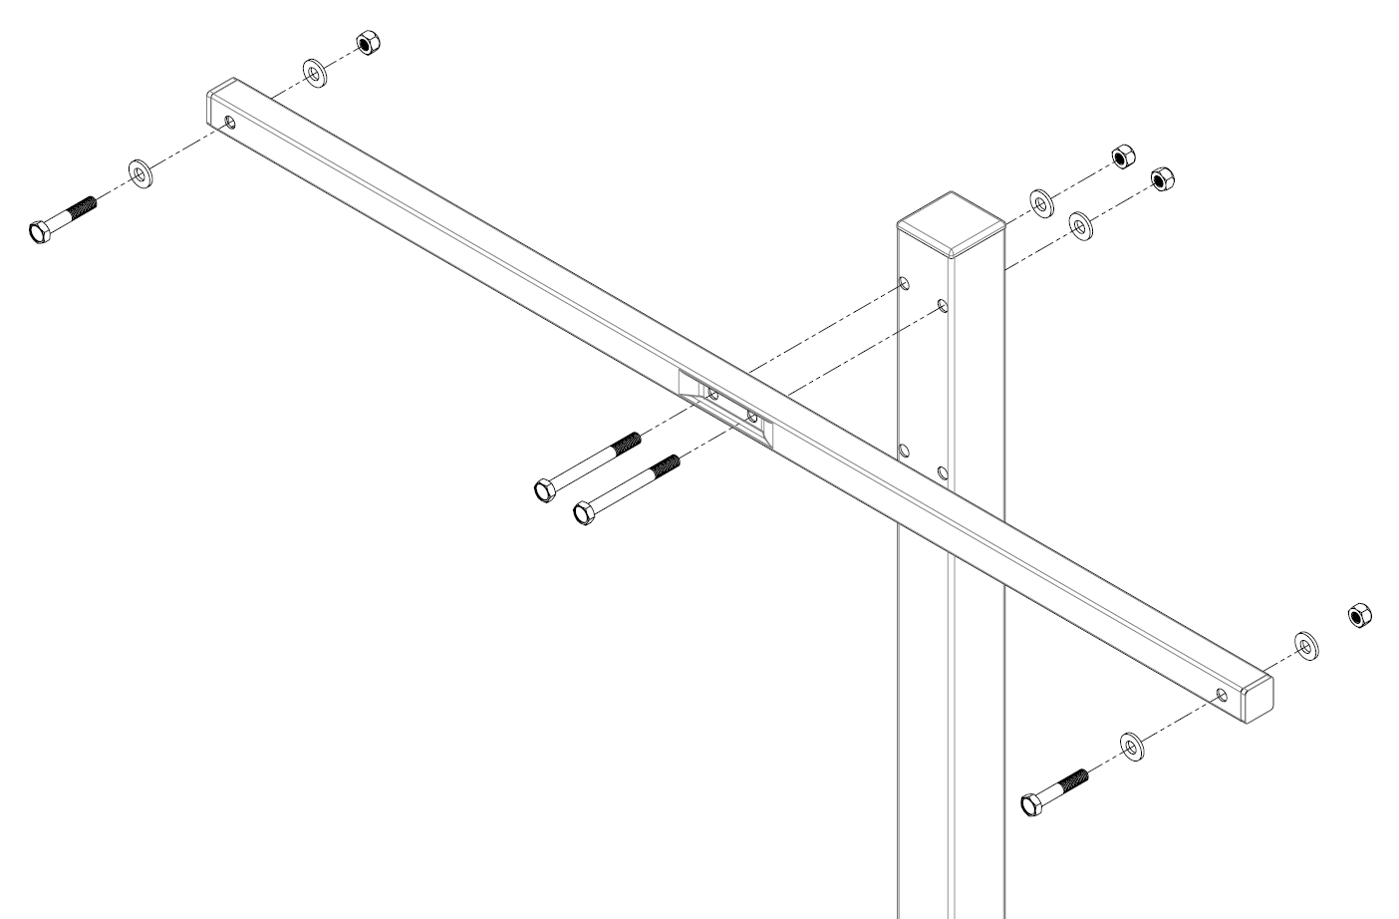
4
5
4
5
5
1
3
2
Assembly
- Secure the Cross Beam to the Post Kit (not included) using items 3, 4 and 5. Ensure the heads of the bolts are within the recess of the Cross Beam.
- Secure the Cabinet of the Retracting Line to the Cross Beam using Items 2, 5 and 4.
Warranty - Terms and Conditions
Any claim under this warranty must be made within ten years of the date of purchase of the product.
To make a claim under the warranty, take the product (with proof of purchase) to any Bunnings store (see www.bunnings.com.au for store locations).
Sales Force National Pty Ltd (t/a Zenexus) bears reasonable, direct, expenses of claiming under the warranty. You may submit details and proof into any Bunnings store for consideration.
The warranty covers manufacturer defects in materials, workmanship and finish under normal use.
This warranty is provided in addition to other rights and remedies you may have under law: our goods come with guarantees which cannot be excluded under the Australian Consumer Law. You are entitled to replacement or refund for a major failure and to compensation for other reasonably foreseeable loss or damage. You are also entitled to have the goods repaired or replaced if the goods fail to be of acceptable quality and the failure does not amount to a major failure. If the clothesline is repaired or partly replaced under warranty the original warranty will not be extended.
The warranty excludes damage resulting from product misuse or product neglect. The warranty covers domestic use only and does not apply to commercial applications.
This warranty is given by Sales Force National Pty Ltd (t/a Zenexus), ABN: 60 110 379 587. Phone: 1300 734 714 (AU), 0800 800 040 (NZ). E-mail: customerservice@zenexus.com.au, customerservice@zenexus.co.nz. Website: www.zenexus.com.au.
WARRANTY EXCLUSIONS
Fading due to weather exposure or damage to the frame and line through accident misuse or negligence.

