TOPDRY Rotary – Handle Replacement - Installation Instructions
Parts List
AD05529 | Handle Assembly - Rotary Evergreen | 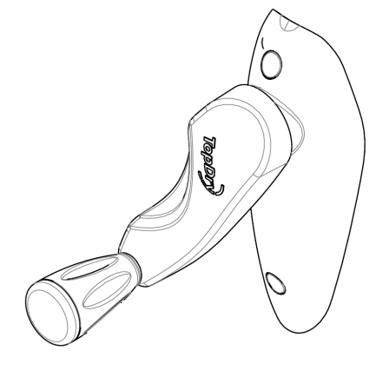
AD05530 | Handle Assembly - Rotary Graphite

Rotary Handle – Removal Instructions
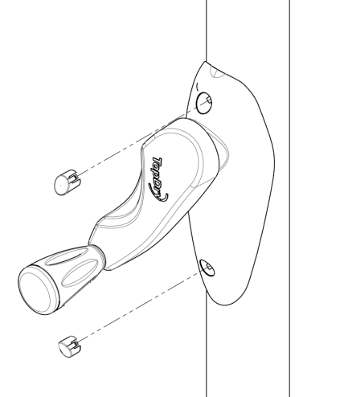 | 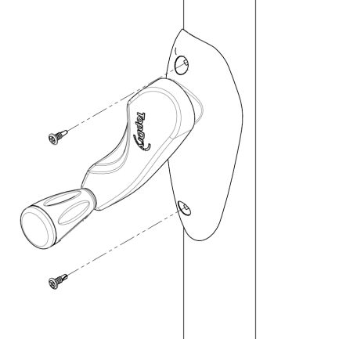 | 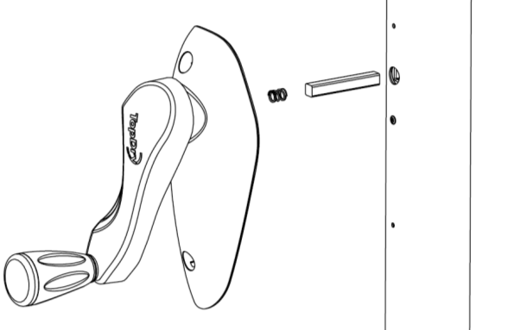
- Use a small flat bladed screwdrive to remove the two small caps | - Use a cross head screwdriver to remove the two screws holding the handle to the main post | - Pull the handle of the square key. Leave the key in place.

Rotary Handle – Removal Instructions
- Align the square key with the handle and position the assembly | - Use a cross head screwdriver to tighten the two screws holding the handle to the main post | - Push the two caps into position.
Sales Force National Pty Ltd (t/a Zenexus), ABN: 60 110 379 587. Phone: 1300 734 714 (AU), 0800 800 040 (NZ). E-mail: customerservice@zenexus.com.au(AU), customerservice@zenexus.co.nz (NZ). Website: www.zenexus.com.au

