TOPDRYRotary– Winding Mechanism -Installation Instructions
Parts List
AD05528 | Winding Mechanism | 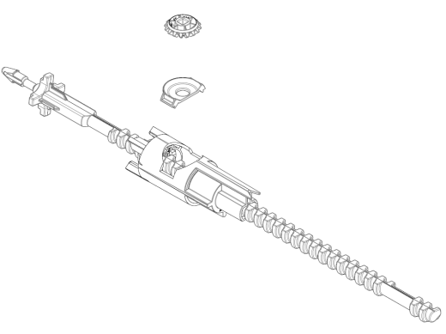

Remove the Winding Mechanism
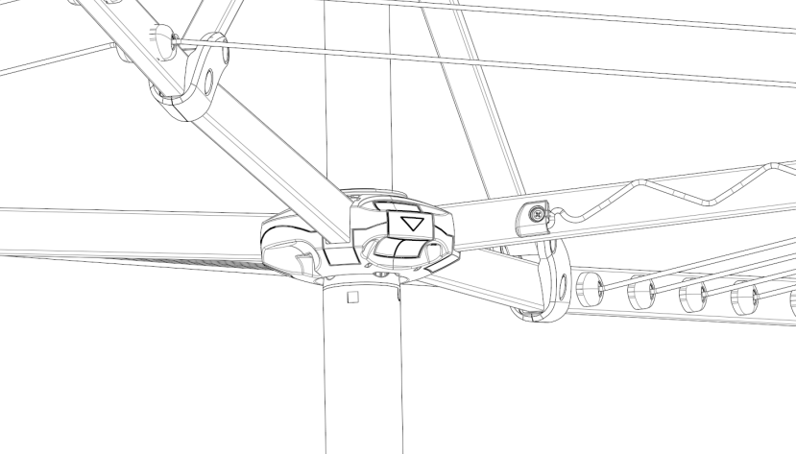 |  | 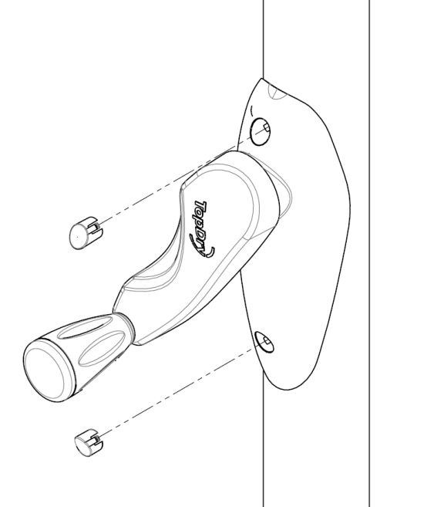
- Fold the Arms of the clothesline. |  | - Remove the two small caps from the Handle Assembly using a fine bladed screwdriver
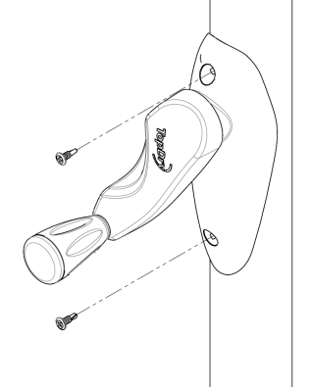 | 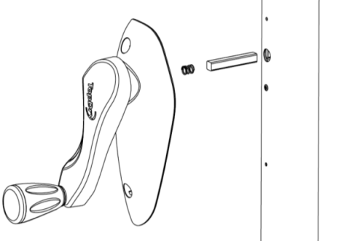
- Unscrew the two screws using a cross head screwdriver | - Remove the Handle Assembly

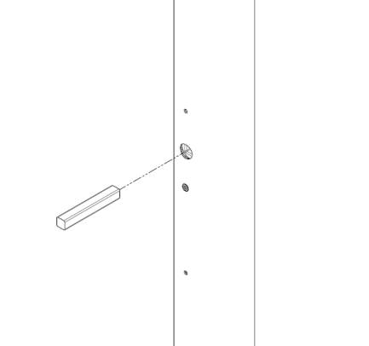 | 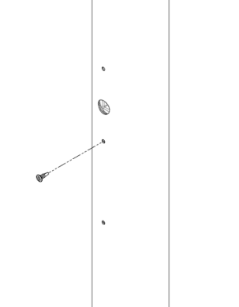
- Remove the square key | - Unscrew the single small screw holding the Winding Mechanism to the Main Post.
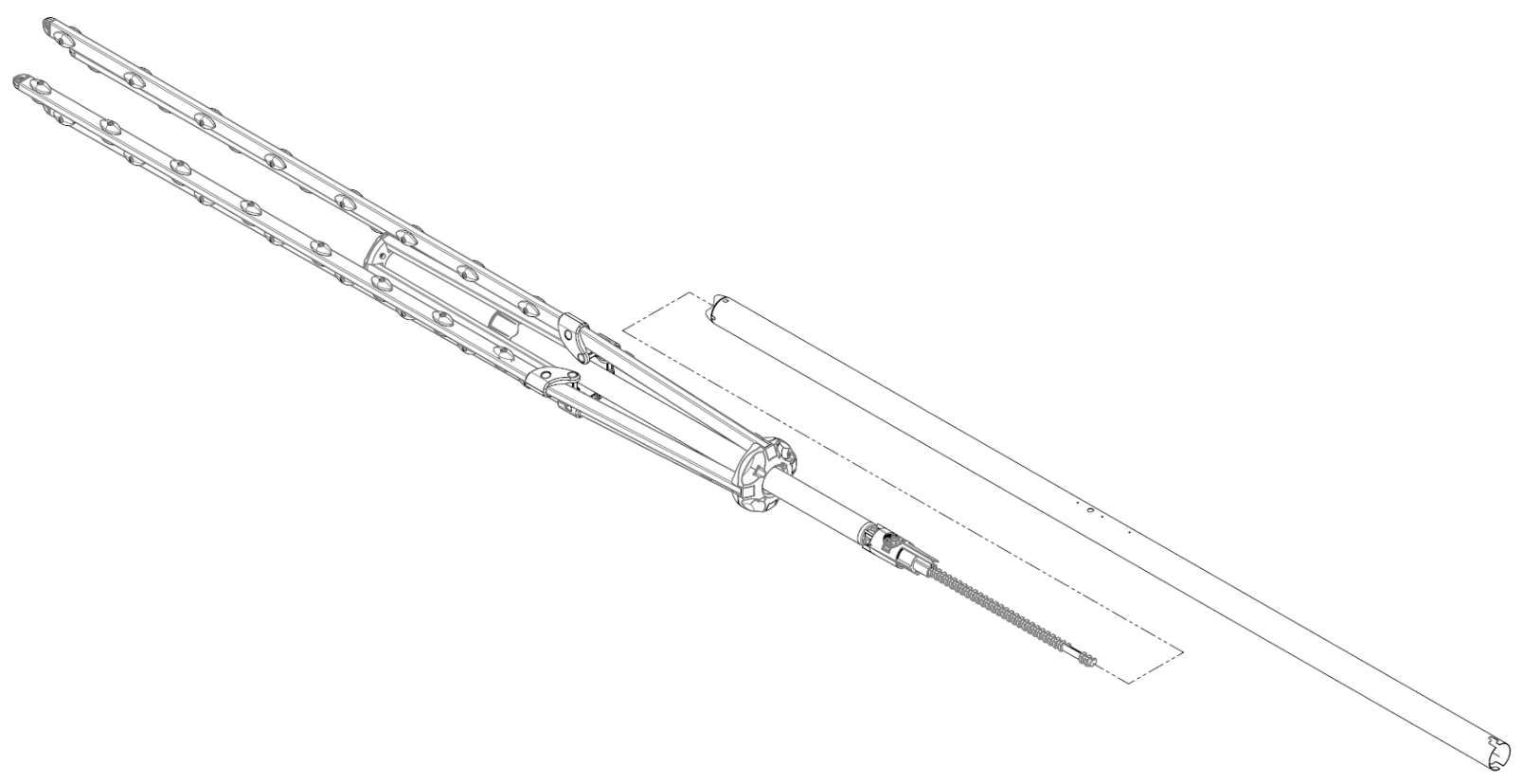
- With Main Post on the ground the gently pull the Arm Assembly from the Main Post – withdrawing the Winding Mechanism

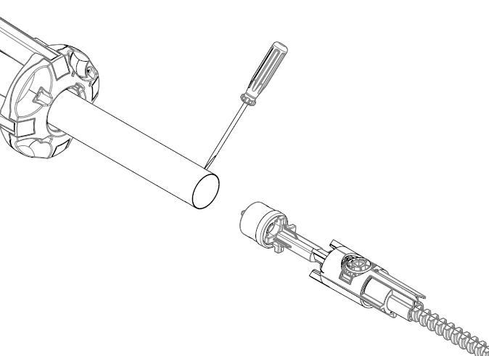 | 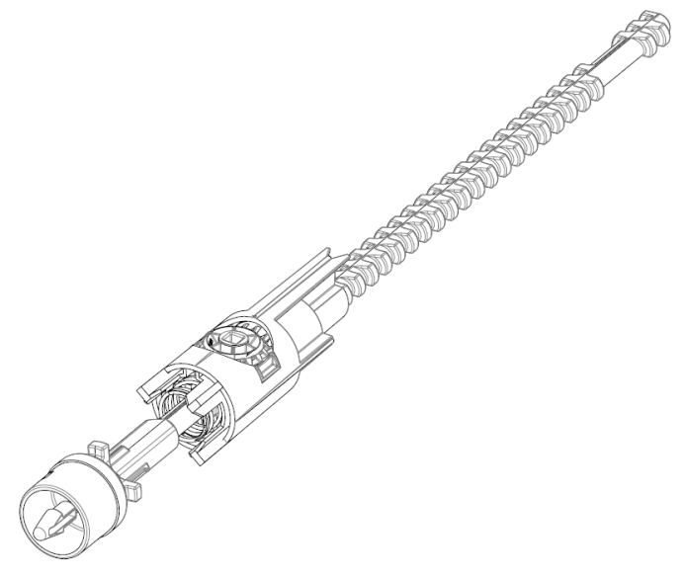
- Use a screw driver to depress the clips securing the End Cap in the Arm Assembly and remove it with the Winding Mechanism. | - Use pliers to compress the barbed snap fit on the end of the Winding Mechanism. Note: this can be cut off if required. Take care to not damage the End Cap as it will be reused.

Fit the new Winding Mechanism
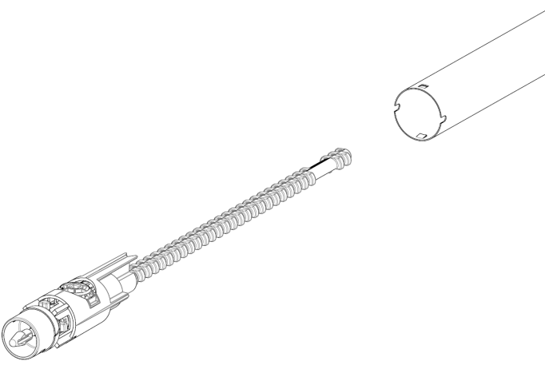
- Ensure the Crown Gear and Carrier are in place and gently insert the new Winding Mechanism into the Main Post until it is aligned with the opening for the square key. Use a small screw driver to rotate the Winding Mechanism if required.

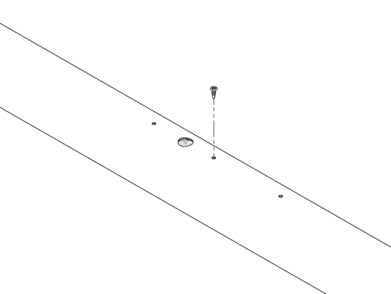 | 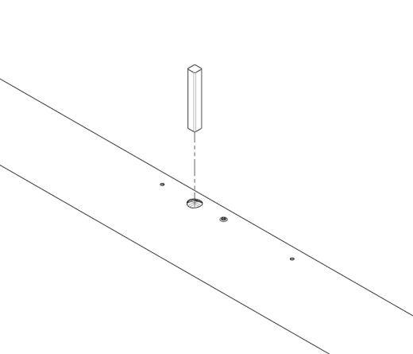
- Secure the Winding Mechanism with the small screw removed in Step 6 | - Insert the square key..

 | 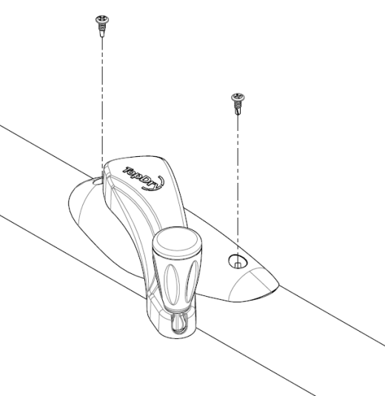
- Refit the Handle Assembly, | - Secure with the two screws removed in Step 3

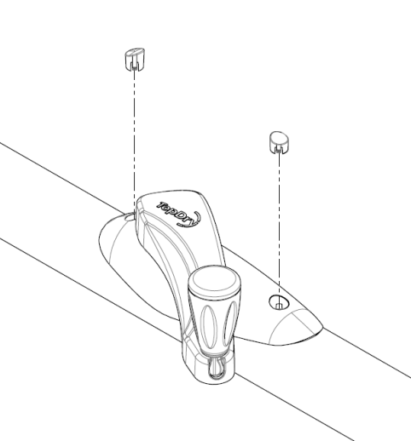 | 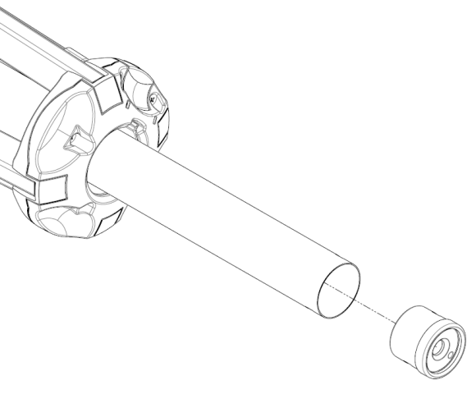
- Push the small cover caps back into place over the screws | - Insert the End Cap back into the Arm Assembly
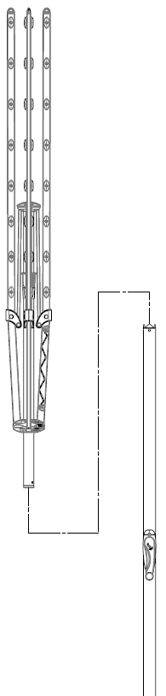 | 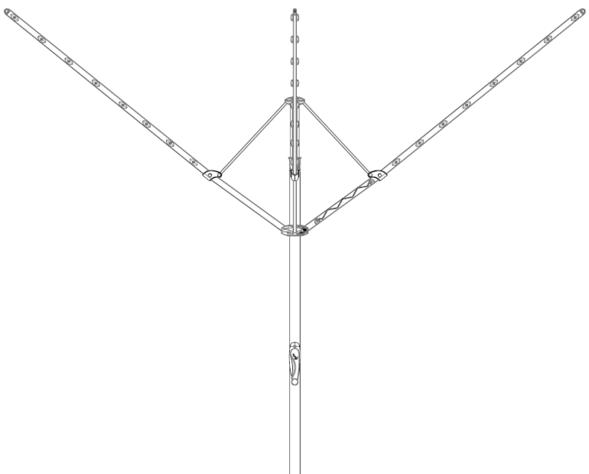
- Return the Main Post to the Ground Socket and then lift the Arm Assembly and align it with the Main Post. Pull it down firmly until there is a ‘click’. Note: once this is clicked into place it cannot be removed without repeating Step 9 | - Open the arms of the clothesline to ensure the lines are not tangled and use the Handle Assembly to raise and lower the clothesline to check its operation.

Sales Force National Pty Ltd (t/a Zenexus), ABN: 60 110 379 587. Phone: 1300 734 714 (AU), 0800 800 040 (NZ). E-mail: customerservice@zenexus.com.au(AU), customerservice@zenexus.co.nz (NZ). Website: www.zenexus.com.au

