TOPDRY Folding Frame – Strut Replacement Installation Instructions
Parts List
AD05512 | Strut Assembly - Smoke | 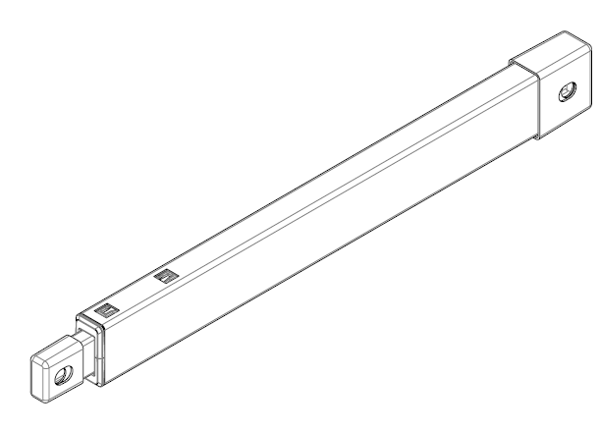
AD05513 | Strut Assembly - Slate

Remove the Strut to be Replaced
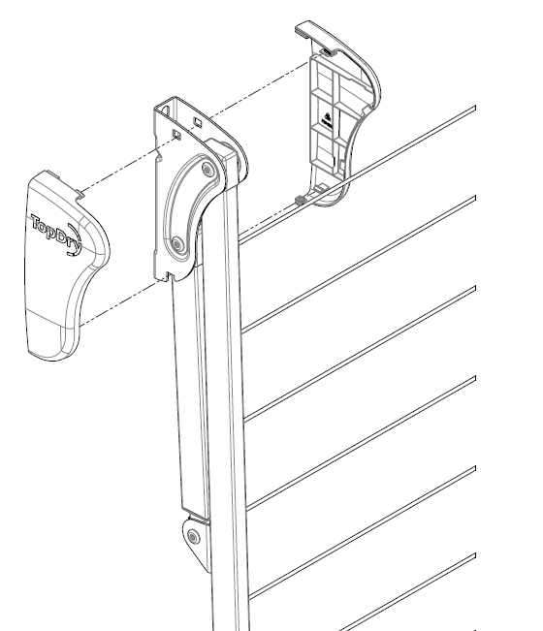 | 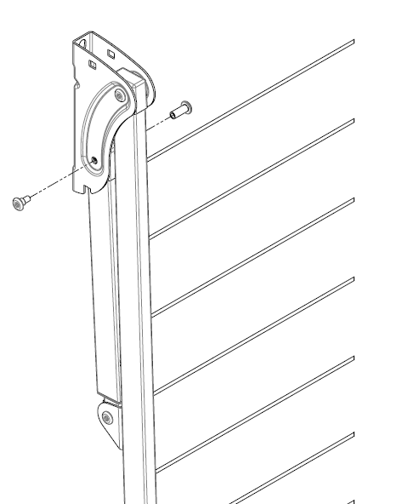
- Unclip the two plastic covers | - With the frame folded. Remove the screws securing the Strut to the Wall Bracket using two 5mm hex keys

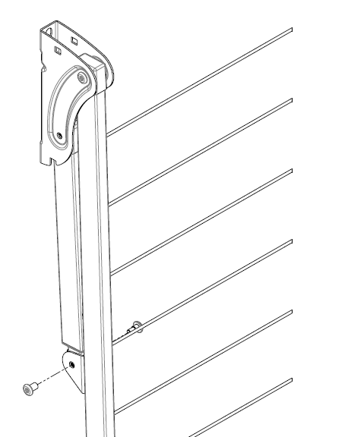 | 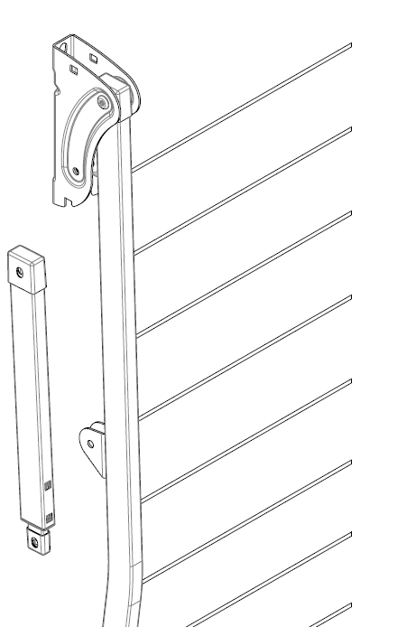
- Remove the screws securing the Strut to Arm using two 5mm hex keys. | - Remove the Strut.

Fit the replacement strut
- Position the new Strut | - Assemble and tighten the screws securing the Strut to the Arm

- Assemble and tighten the screws securing the Strut to Wall Bracket | - Clip the plastic covers into position.
Sales Force National Pty Ltd (t/a Zenexus), ABN: 60 110 379 587. Phone: 1300 734 714 (AU), 0800 800 040 (NZ). E-mail: customerservice@zenexus.com.au(AU), customerservice@zenexus.co.nz (NZ). Website: www.zenexus.com.au

