TOPDRY Portable – Hinge Replacement Installation Instructions
Remove the Hinge to be Replaced
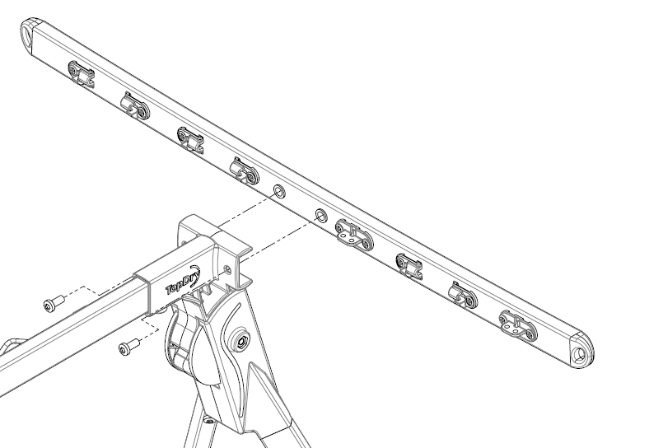 | 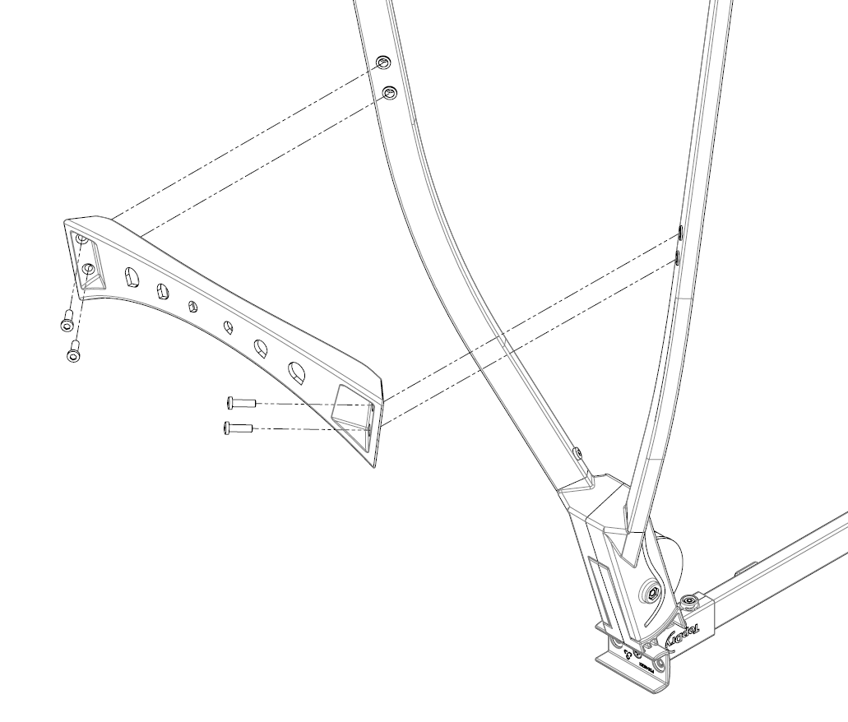
- Unthread the lines and remove the arm from each end | - Turn upside down and remove the brace from each end
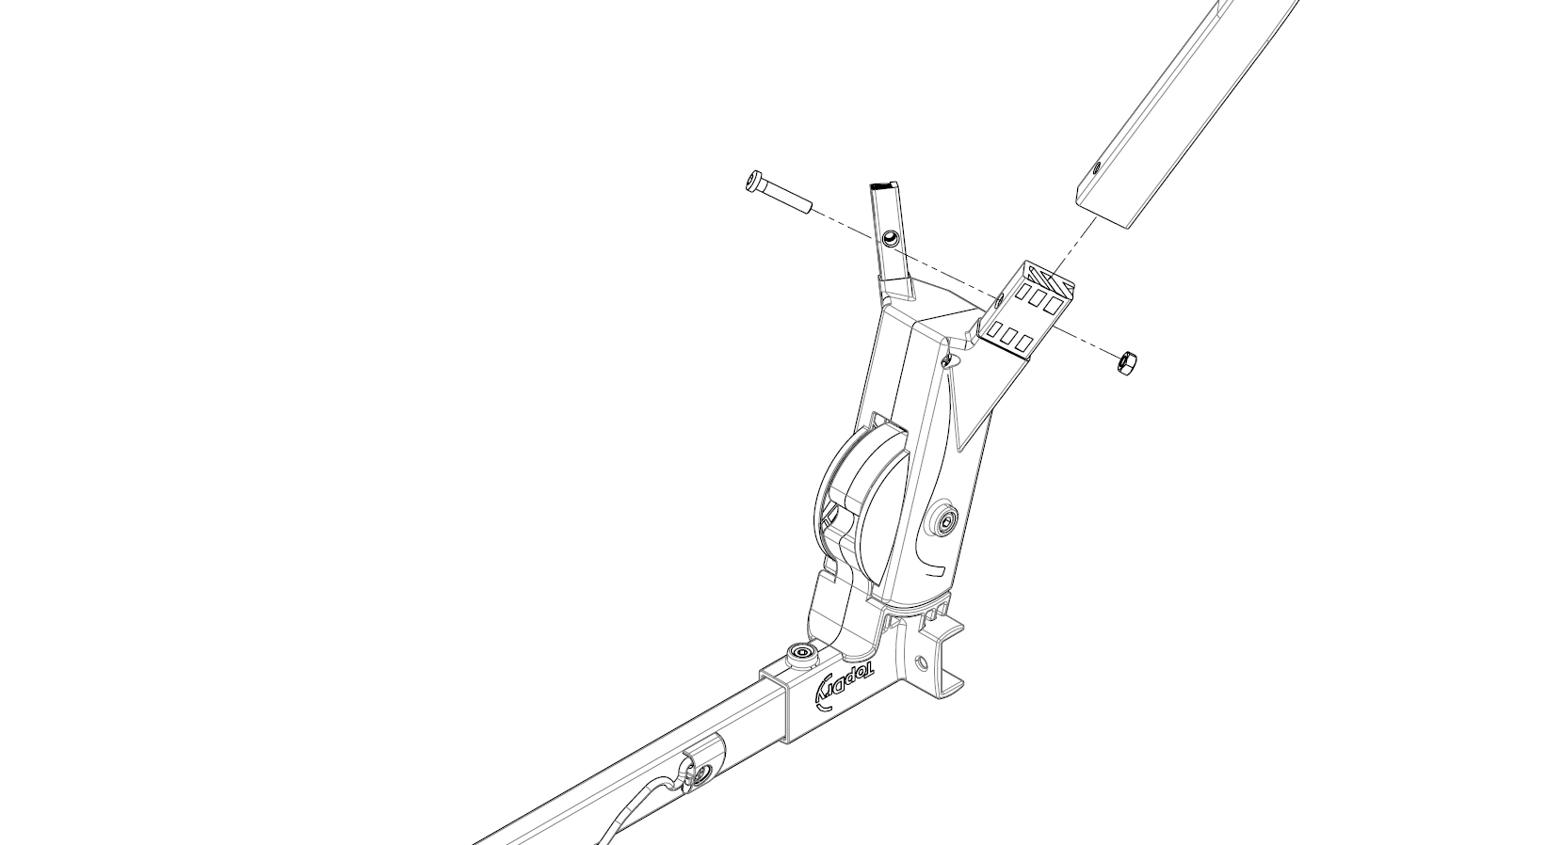 | 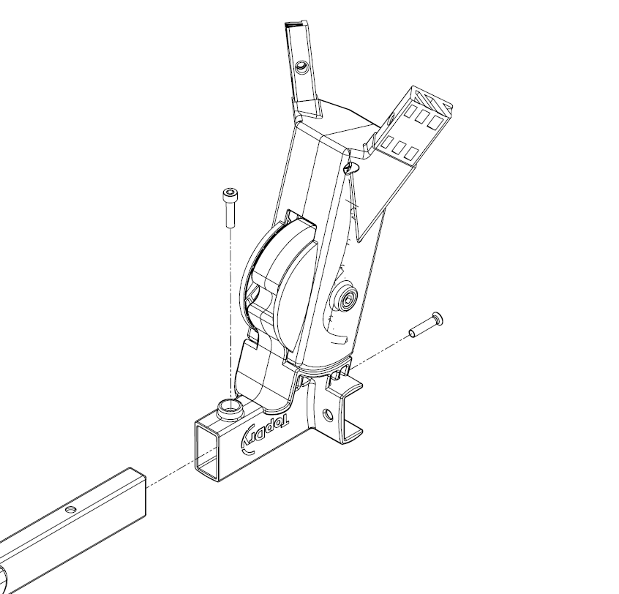
- Unscrew the legs from the Hinge | - Unscrew the centre bar from the hinge
Fit the replacement hinge
- Fit the new hinge to the centre ba | - Fit the legs to the new hinge
- Refit the brace to the legs | - Refit the arms to each end

Thread and Tension the Lines
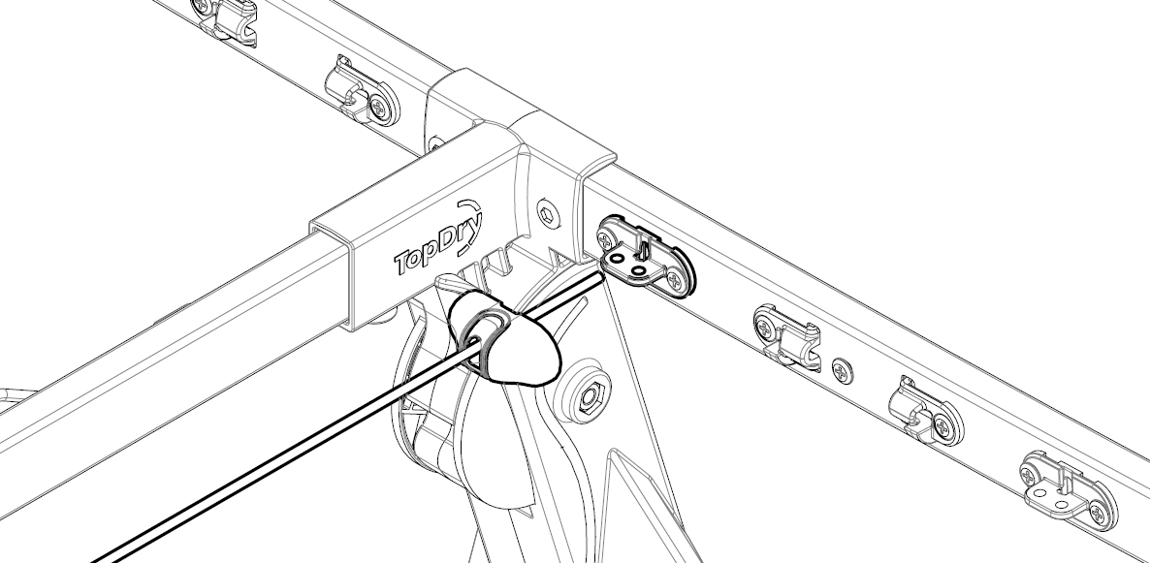 | 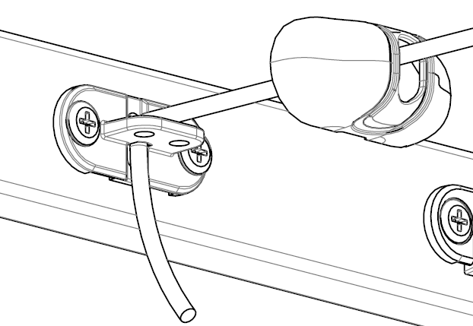
- Thread the cap over the line end | - Pull the line down through the tensioner
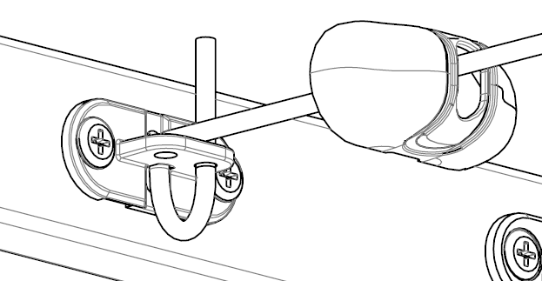 | 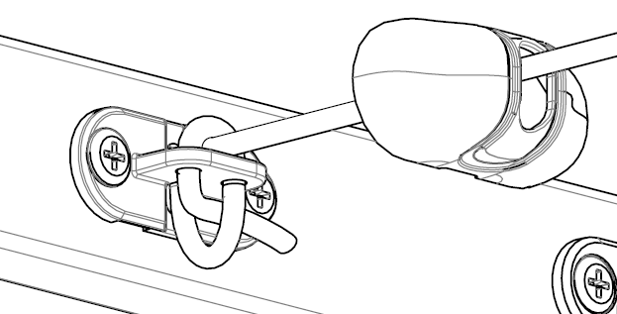
- Loop the line up through the tensioner | - Thread the the line over, down and then through the loop

Thread and Tension the lines (cont.)
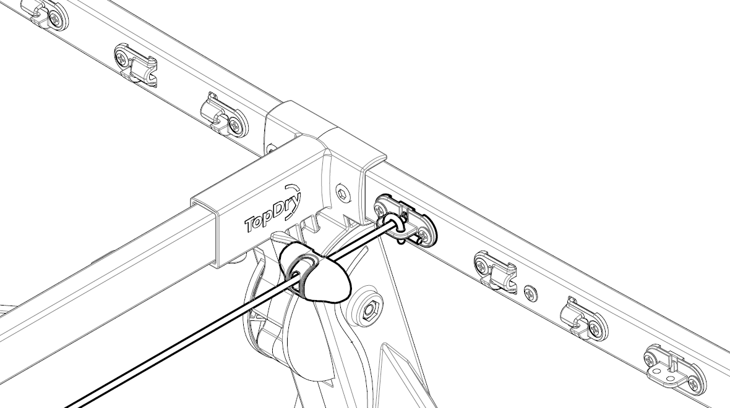 | 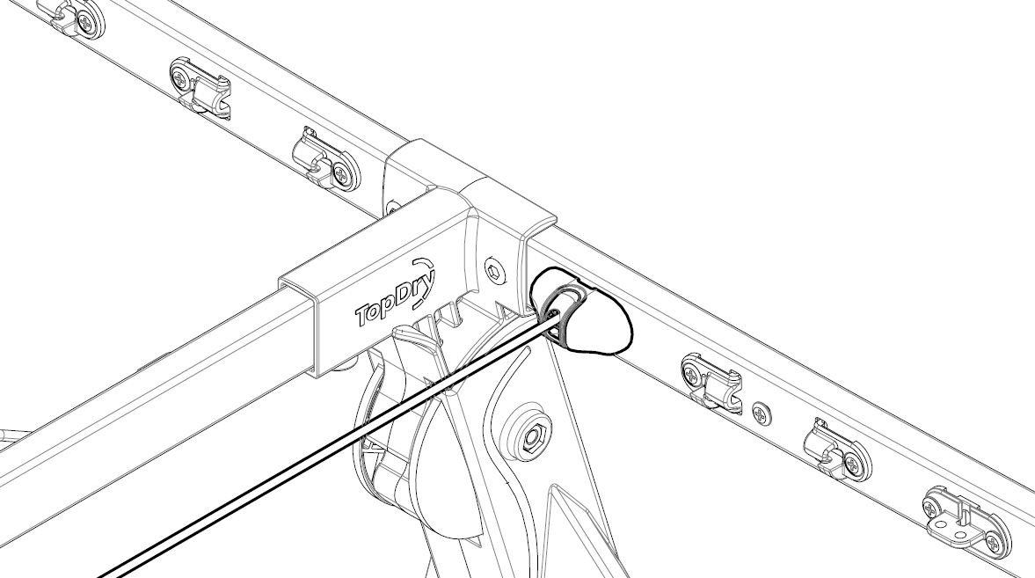
- Trim the end of the line | - Fit the cap
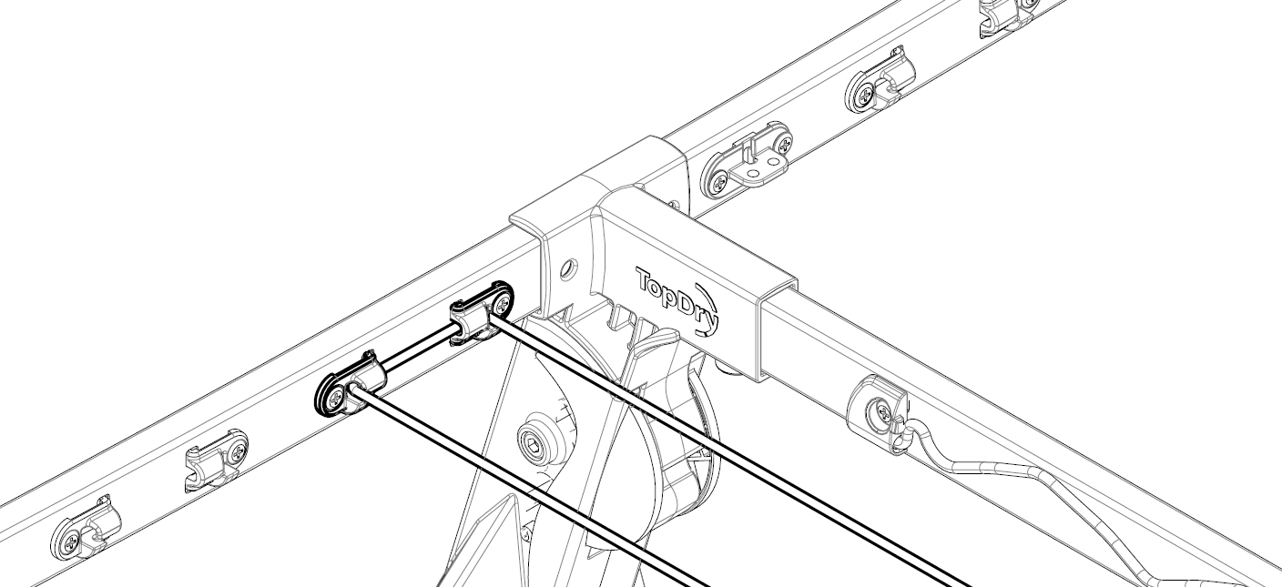
- Feed the line through the line hooks and fit covers | - Follow this pattern to thread the lines
Notes: Over time the line may stretch and cause the lines to sag. This can be corrected by pulling the lines tight and re-tensioning, cutting off any excess so that the Tensioner Cover can be refitted. Take care not to over tension the lines as this may cause the arms to be distorted.
Sales Force National Pty Ltd (t/a Zenexus), ABN: 60 110 379 587. Phone: 1300 734 714 (AU), 0800 800 040 (NZ). E-mail: customerservice@zenexus.com.au(AU), customerservice@zenexus.co.nz (NZ). Website: www.zenexus.com.au

