TOPDRY Folding Frame – Wall Bracket Cover Replacement - Installation Instructions
Parts List
AD05514 | Wall Bracket Double Cover - Smoke | 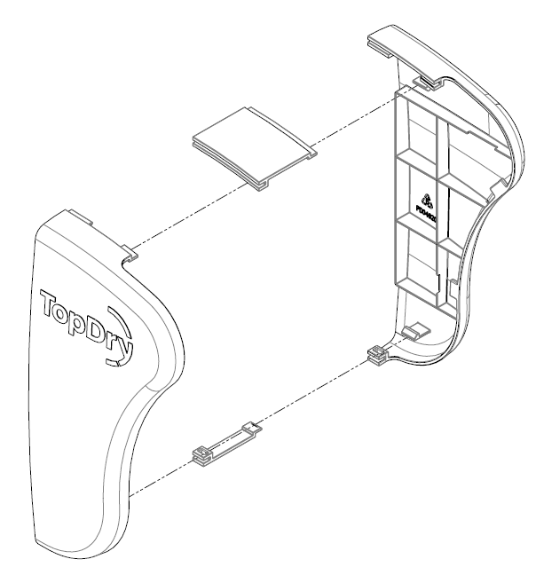
AD05515 | Wall Bracket Double Cover - Slate
AD05516 | Wall Bracket Single Cover - Smoke | 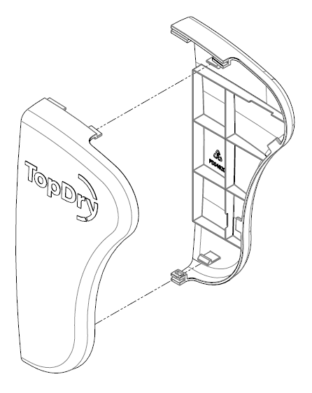
AD05517 | Wall Bracket Single Cover - Slate

Wall Bracket Single - Cover Fitting Instructions
- To remove, unclip the covers by pulling gently.
- To Replace, fix the Covers onto the Wall Bracket by aligning the clips with the openings on the Wall Bracket and pushing gently.

Wall Bracket Double - Cover Fitting Instructions
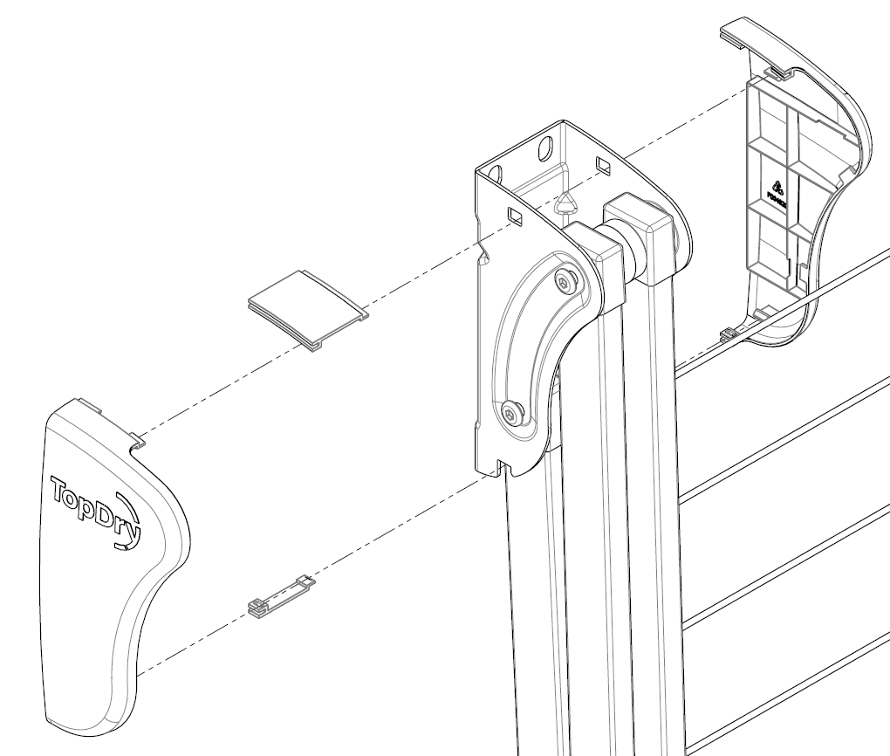
- To Remove, unclip the covers by pulling gently and remove the upper and lower infill pieces.
- To replace, fit the upper and lower infill pieces and attach the covers to the Wall Bracket by aligning the clips with the openings on the Wall Bracket and pushing gently.
Sales Force National Pty Ltd (t/a Zenexus), ABN: 60 110 379 587. Phone: 1300 734 714 (AU), 0800 800 040 (NZ). E-mail: customerservice@zenexus.com.au(AU), customerservice@zenexus.co.nz (NZ). Website: www.zenexus.com.au

