TOPDRY Folding Frame – Handle Replacement Installation Instructions
Parts List
AD05520 | Handle - Smoke | 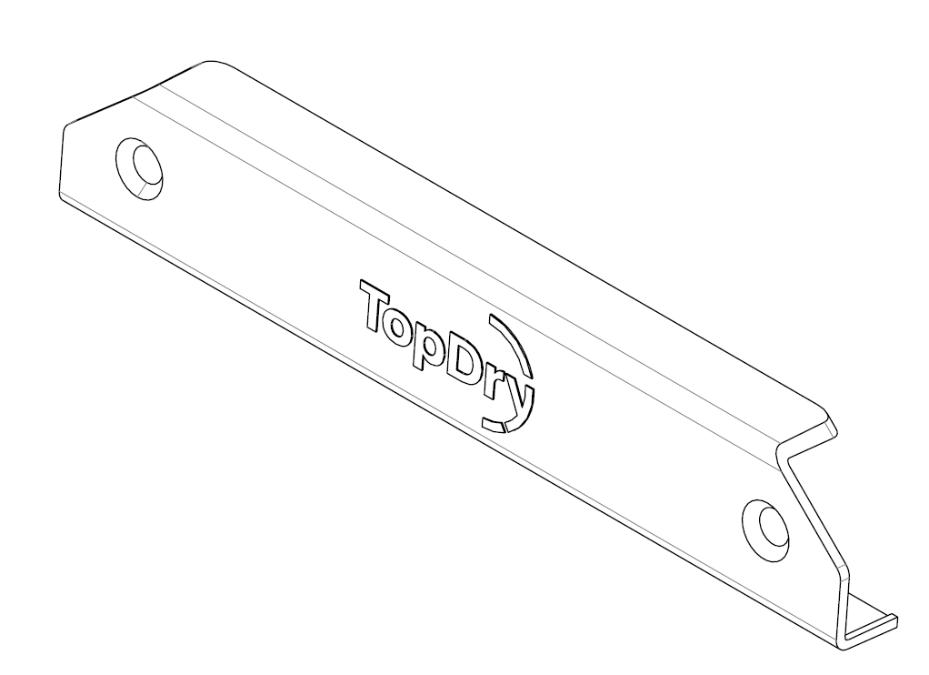
AD05521 | Handle - Slate

Remove the Handle to be Replaced
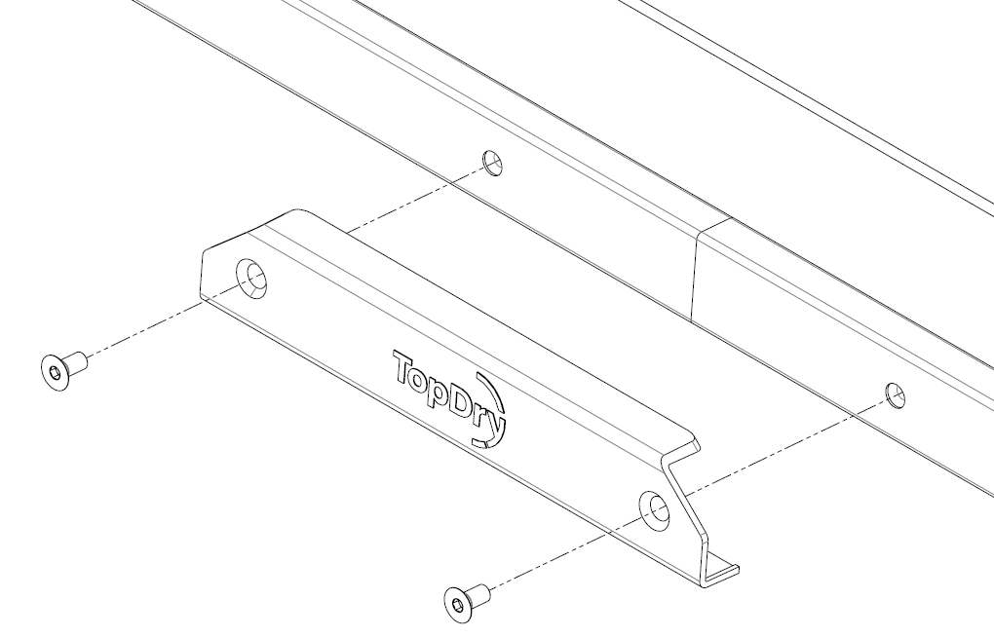
- Undo the two screws using a 4mm hex key and remove the handle.
- Position the new handle and secure by tightening the two screws using a 4mm hex key.
Sales Force National Pty Ltd (t/a Zenexus), ABN: 60 110 379 587. Phone: 1300 734 714 (AU), 0800 800 040 (NZ). E-mail: customerservice@zenexus.com.au(AU), customerservice@zenexus.co.nz (NZ). Website: www.zenexus.com.au

