TOPDRY Retracting Line – Grommet Installation Instructions
Parts List
AD05527 | Line Hook | 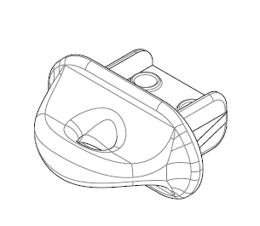

Remove the Line Hook
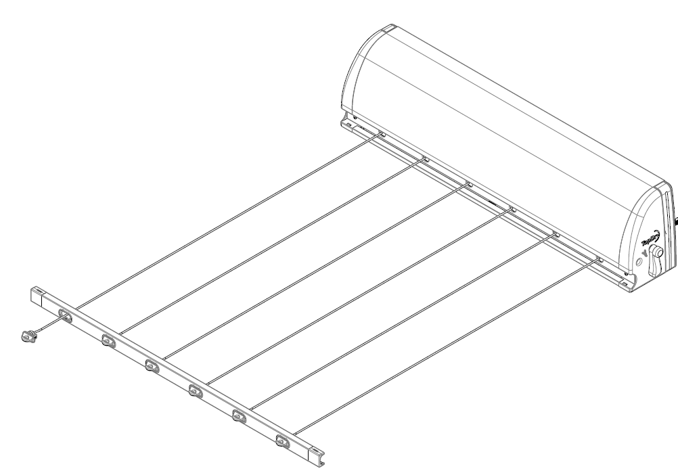  1  2 | 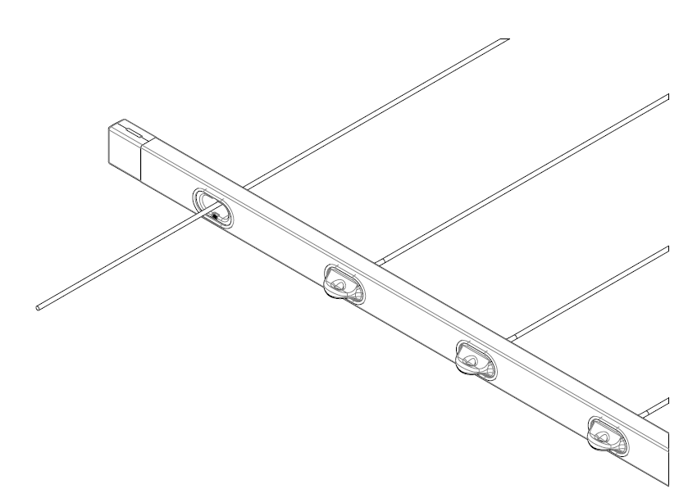
- Pull out the Front Bar at least 1 metre and extend the line with the Line Hook to be changed an additional 100mm  - Lock the line tensioner | - Unthread the line from the Line Hook to be replaced.

Fit the new Line Hook
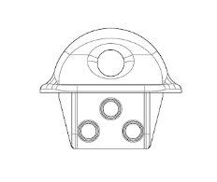  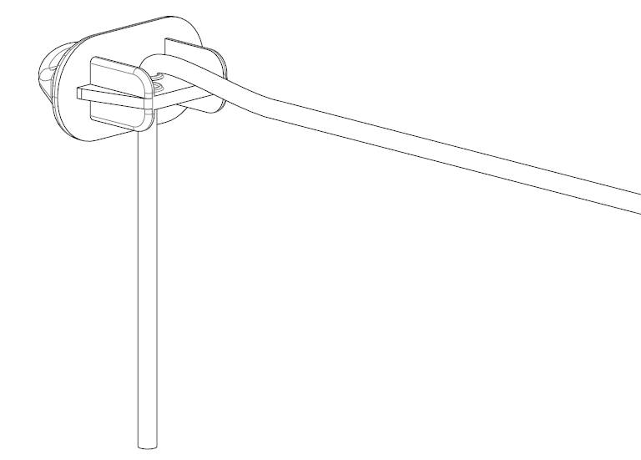 | 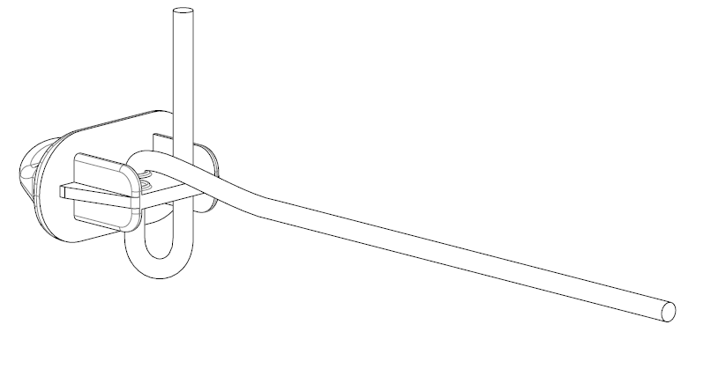
- Thread the line down through the Line Hook | - Loop the line up through the Line Hook
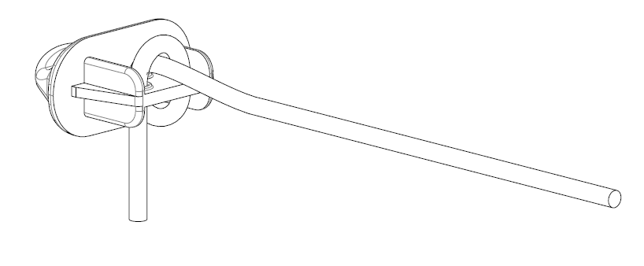 | 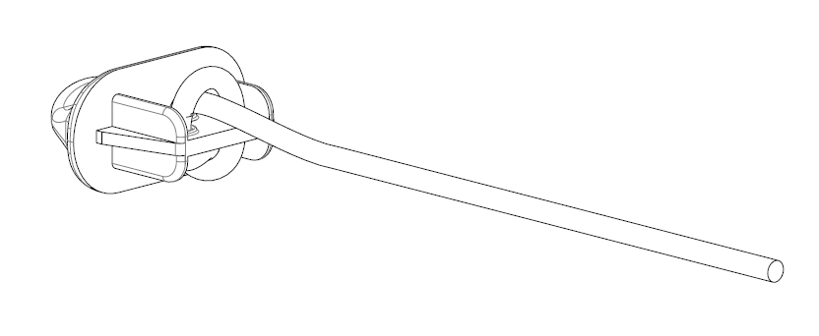
- Loop the the line over and down | - Insert the end of the line in the loop fromed in step 4 and tighten

Sales Force National Pty Ltd (t/a Zenexus), ABN: 60 110 379 587. Phone: 1300 734 714 (AU), 0800 800 040 (NZ). E-mail: customerservice@zenexus.com.au(AU), customerservice@zenexus.co.nz (NZ). Website: www.zenexus.com.au

