TOPDRY Retracting Line – Receiving Bracket Installation Instructions
Parts List
AD05525 | Receiving Bracket | 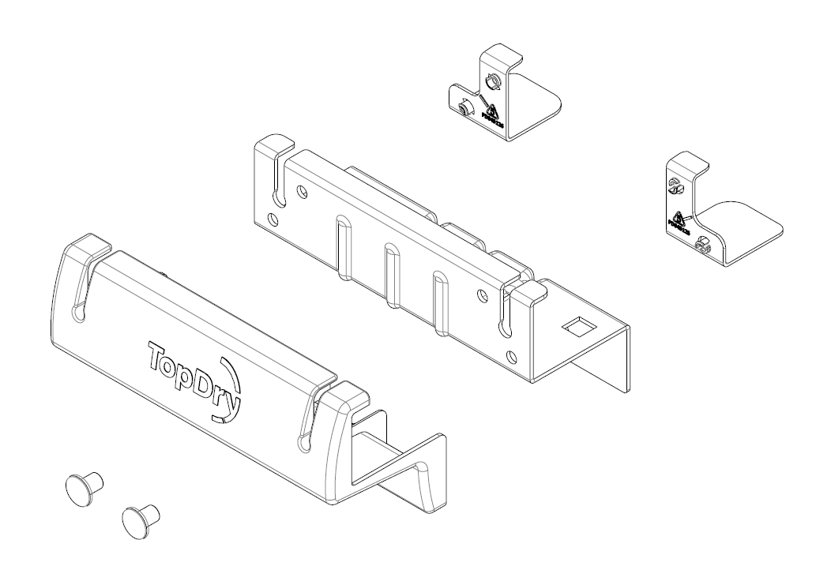

Replace the Receiving Bracket
- Undo the two the original fasteners securing the bracket to the wall or post
- Press the blanking plugs into the mounting holes that will not be used. Outer holes are for wall mounting, inner holes are for post mounting.
- Ensure the plastic spacers and the cover are clipped onto the metal bracket
- Secure the new Receiving Bracket to wall or post.
Sales Force National Pty Ltd (t/a Zenexus), ABN: 60 110 379 587. Phone: 1300 734 714 (AU), 0800 800 040 (NZ). E-mail: customerservice@zenexus.com.au(AU), customerservice@zenexus.co.nz (NZ). Website: www.zenexus.com.au

