TOPDRY Retracting – Adjustable Post Kit
Safety Tips

Only use your clothesline to hang and dry washing.

Remember the clothesline is not a children’s toy

Don’t use your clothesline if it or the Post Kit is damaged

Note the following for future reference
Product Name
Date of purchase:
Place of purchase:

Package Contents
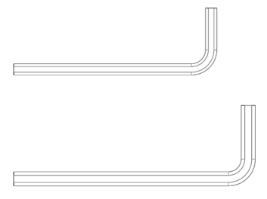
10
9
8
7
6
5
4
3
2
1

Item | Description | Quantity |  | Item | Description | Quantity
1 | Upper Post | 1 |  | 6 | M8 Nut | 2
2 | Bottom Post | 1 |  | 7 | M6 Washer | 4
3 | M6 x 65mm Socket Head Screw | 2 |  | 8 | M8 Washer | 4
4 | M8 x 70mm Hex Head Bolt | 2 |  | 9 | 4mm Hex Key | 1
5 | M6 Nut | 2 |  | 10 | 5mm Hex Key | 1
Note: An optional ground socket is available that will allow you to remove the post from the ground.

- Install your Adjustable Post Kit
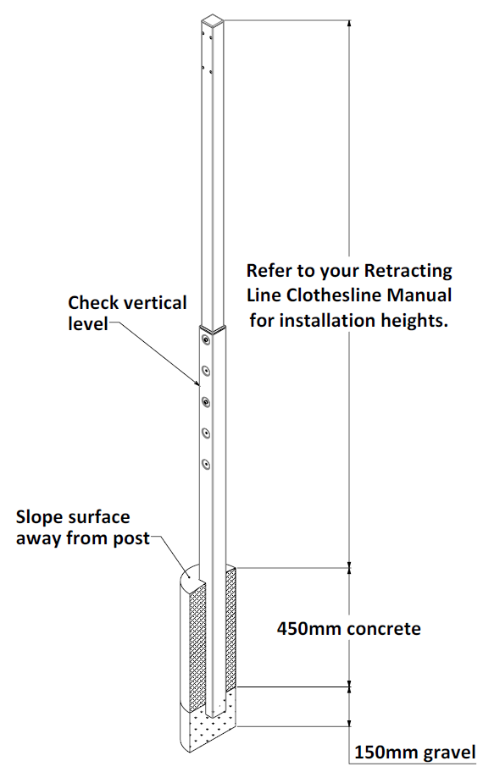

- Insert the upper post into the bottom post, and secure with the fasteners supplied.
- Refer to you Retracting Line manual for site selection and cabinet installation details.
- Dig a hole 600mm deep and 200mm in diameter
- Put 150mm of dry gravel in the hole
- Position the post in the centre of the hole and pushing the post into the gravel set the correct height (refer to your Retracting Line manual).
- Check the post is vertically level
- Concrete the post into position. Make sure to slope the top of the concrete away from the post for drainage.
- Re-check that the post is level and allow the concrete to set for at least 48 hours.
IMPORTANT
- To mount a Retracting Clothesline, you must use a matching Cross Beam
- Follow your Retracting Line instructions to assemble your product to the Cross Beam

- Adjust your Post Kit
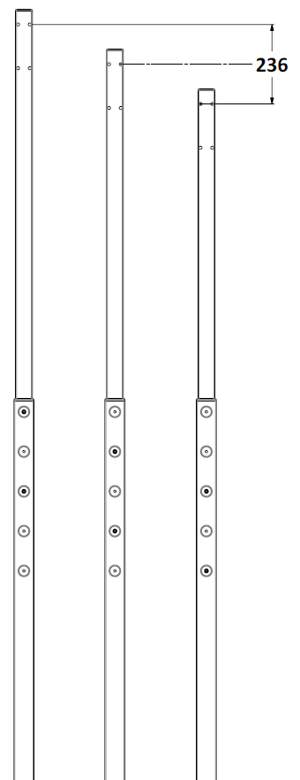 | 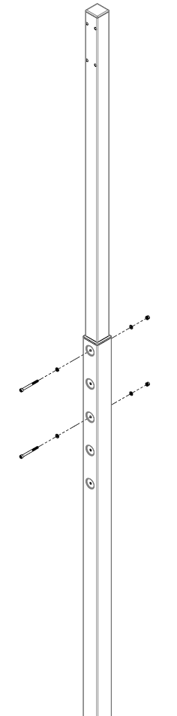

- The Adjustable post kit can be changed between three positions.
- To change the height, undo the two nuts, bolts and washers, raise or lower to the next setting and re-tighten.
- Refer to your Retracting Line Manual for mounting height suggestions

Warranty - Terms and Conditions
Any claim under this warranty must be made within ten years of the date of purchase of the product. Please note that the PVC line is only covered for 12 months from date of purchase.
To make a claim under the warranty, take the product (with proof of purchase) to any Bunnings store (see www.bunnings.com.au for store locations).
Sales Force National Pty Ltd (t/a Zenexus) bears reasonable, direct, expenses of claiming under the warranty. You may submit details and proof into any Bunnings store for consideration.
The warranty covers manufacturer defects in materials, workmanship and finish under normal use.
This warranty is provided in addition to other rights and remedies you may have under law: our goods come with guarantees which cannot be excluded under the Australian Consumer Law. You are entitled to replacement or refund for a major failure and to compensation for other reasonably foreseeable loss or damage. You are also entitled to have the goods repaired or replaced if the goods fail to be of acceptable quality and the failure does not amount to a major failure. If the clothesline is repaired or partly replaced under warranty the original warranty will not be extended
The warranty excludes damage resulting from product misuse or product neglect. The warranty covers domestic use only and does not apply to commercial applications.
This warranty is given by Sales Force National Pty Ltd (t/a Zenexus), ABN: 60 110 379 587. Phone: 1300 734 714 (AU), 0800 800 040 (NZ). E-mail: customerservice@zenexus.com.au, customerservice@zenexus.co.nz. Website: www.zenexus.com.au
WARRANTY EXCLUSIONS
Fading due to weather exposure or damage to the frame and line through accident misuse or negligence

