TOPDRY Folding Frame – Tensioner Cover Set Installation Instructions
Parts List
AD05507 | Tensioner Cover Set – Double Frame – Slate | 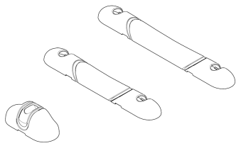  x4  x4  x5
AD05508 | Tensioner Cover Set – Double Frame – Smoke | x4  x4  x5
AD05509 | Tensioner Cover Set – Single Frame – Smoke | 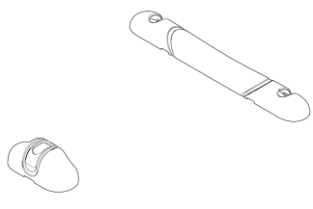  x2  x9
AD00510 | Tensioner Cover Set – Single Frame – Slate | 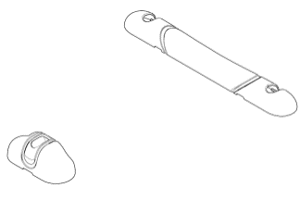  x2  x9
AD05511 | Tensioner Cover Set – Mini Slim and Long Frame | x2

Remove the old Tensioner Cover
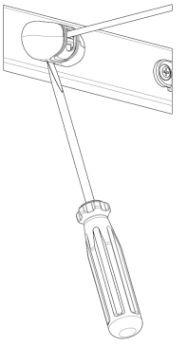 | 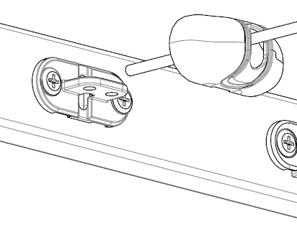
Use a flat bladed screwdriver to unclip the Tensioner Cover from the arm. | Unthread the line and remove the Tensioner Cover.

Remove the old Line Hook Cover
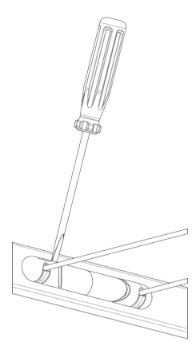 | 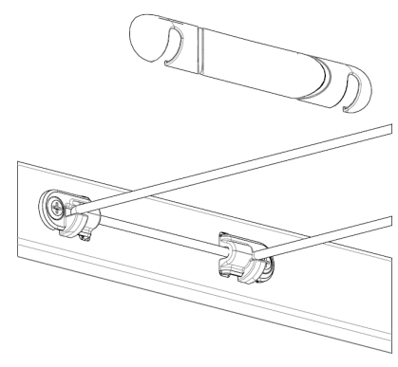
Use a flat bladed screwdriver to unclip the Line Hook Cover from the arm | The Line Hook Cover has slots so it can be lifted upwards without removing the line

Fit the new Tensioner Covers, Line Hook Covers and re-thread the line.
- Thread the Tensioner Cover over the end of the line
- Pull the line down through the tensioner
- Loop the line back up through the right hand hole leaving a loop below
- Loop the line over and thread the line down the left hand hole pulling tight, feed the end of the line through the loop
- Pull tight and trim the excess length
- Clip the Tensioner Cover into position
- Clip Line Hook Covers into positon. Note: TOPDRY Double uses small Line Hook Covers on the inner frame and large Line Hook Covers on the outer frame.
 | 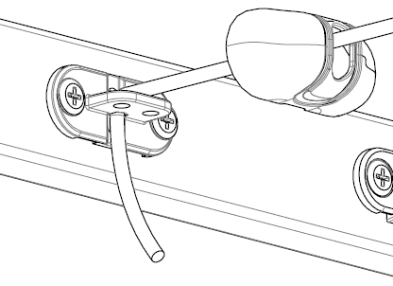 | 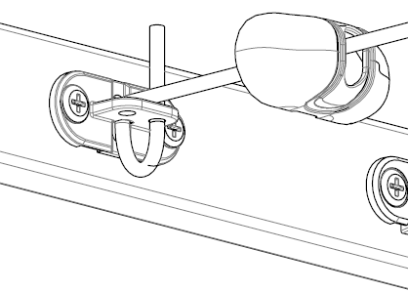 | 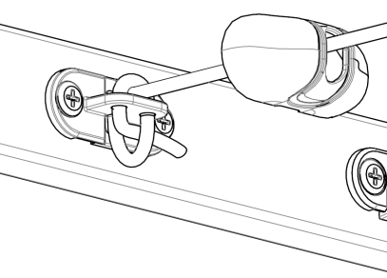
Step 1 | Step 2 | Step 3 | Step 4
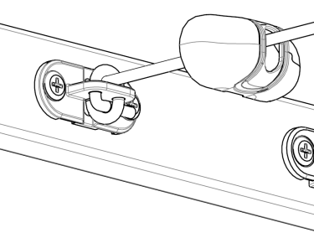 | 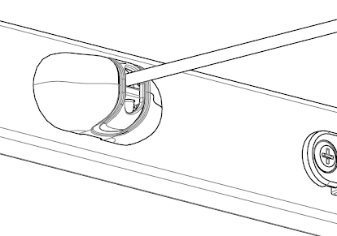 | 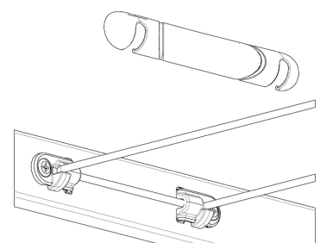
Step 5 | Step 6 | Step 7
Notes:
Over time the line may stretch and cause the lines to sag. This can be corrected by pulling the lines tight and re-tensioning, cutting off any excess so that the Tensioner Cover can be refitted. Take care not to over tension the lines as this may cause the arms to be distorted.
Sales Force National Pty Ltd (t/a Zenexus), ABN: 60 110 379 587. Phone: 1300 734 714 (AU), 0800 800 040 (NZ). E-mail: customerservice@zenexus.com.au(AU), customerservice@zenexus.co.nz (NZ). Website: www.zenexus.com.au

