TOPDRY Retracting – Spool - Installation Instructions
Parts List
AD05524 | Spool Assembly | 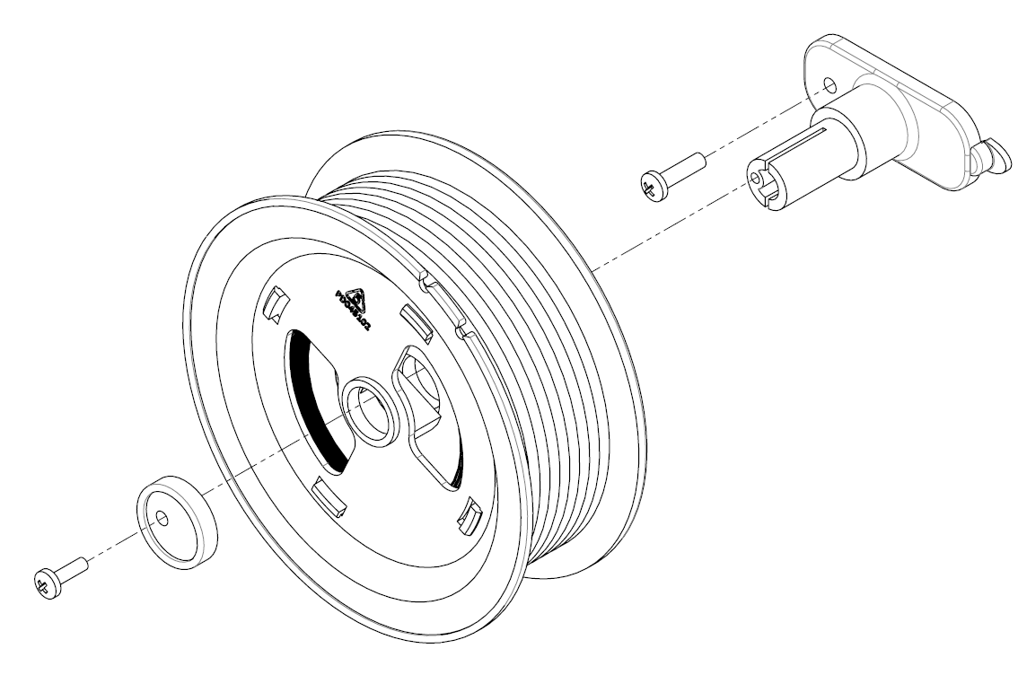

Remove the Spool Assembly
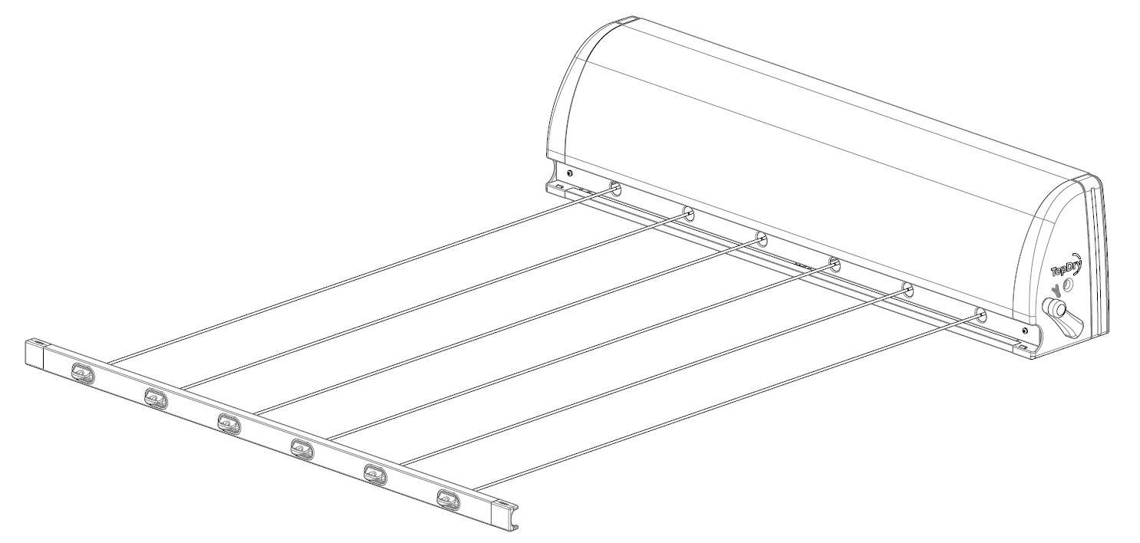
- Remove the Retracting Line Cabinet from the wall or post mounting, extend the lines approximately 1 meter and lock the tensioner.

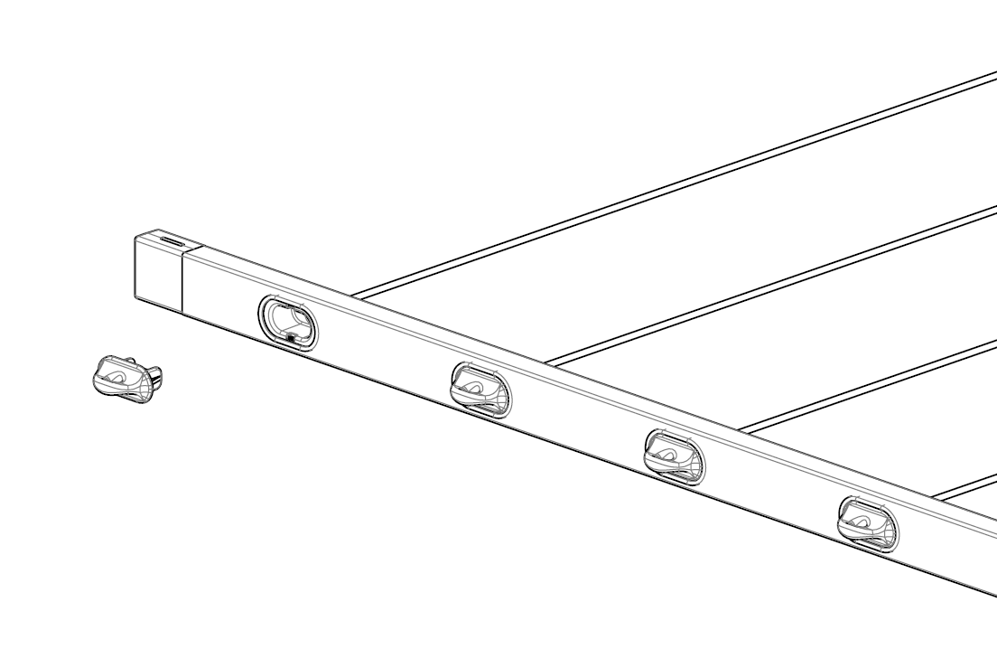
- Undo the line from the Line Hook of the of the spool to be replaced.

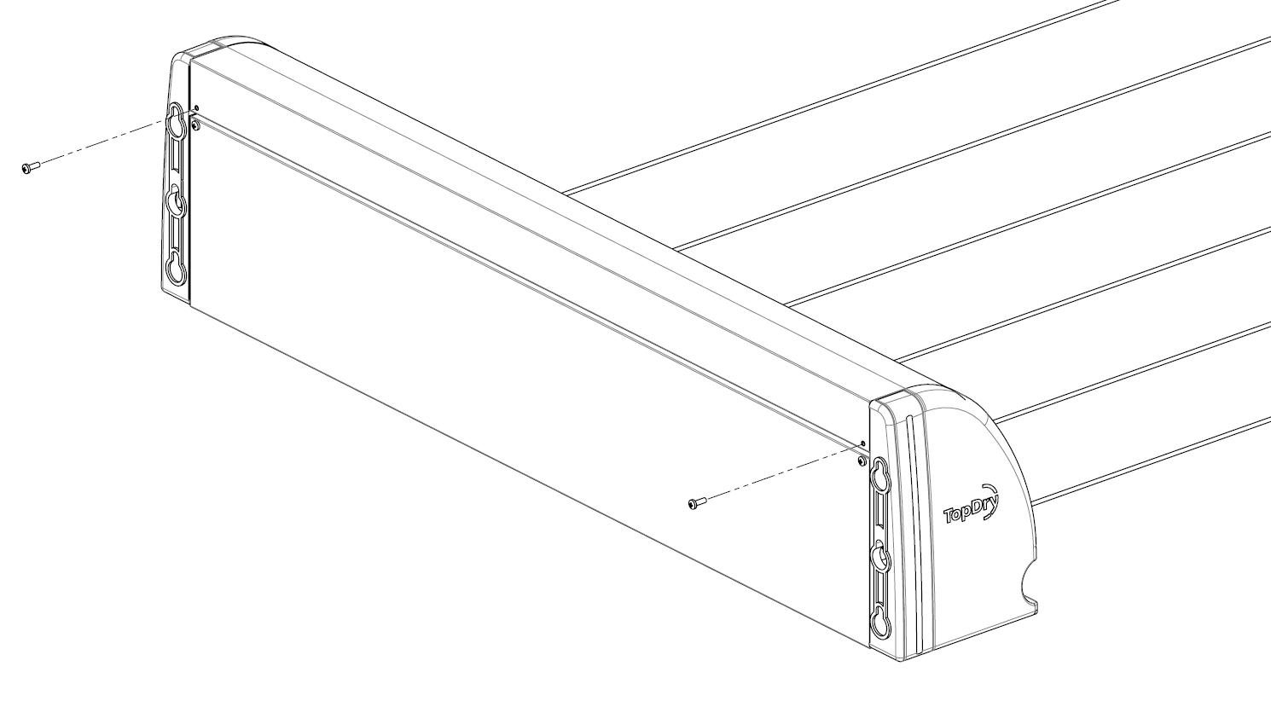
- Remove the two upper screws from the rear of the cabinet that secure the upper metal cover panel.

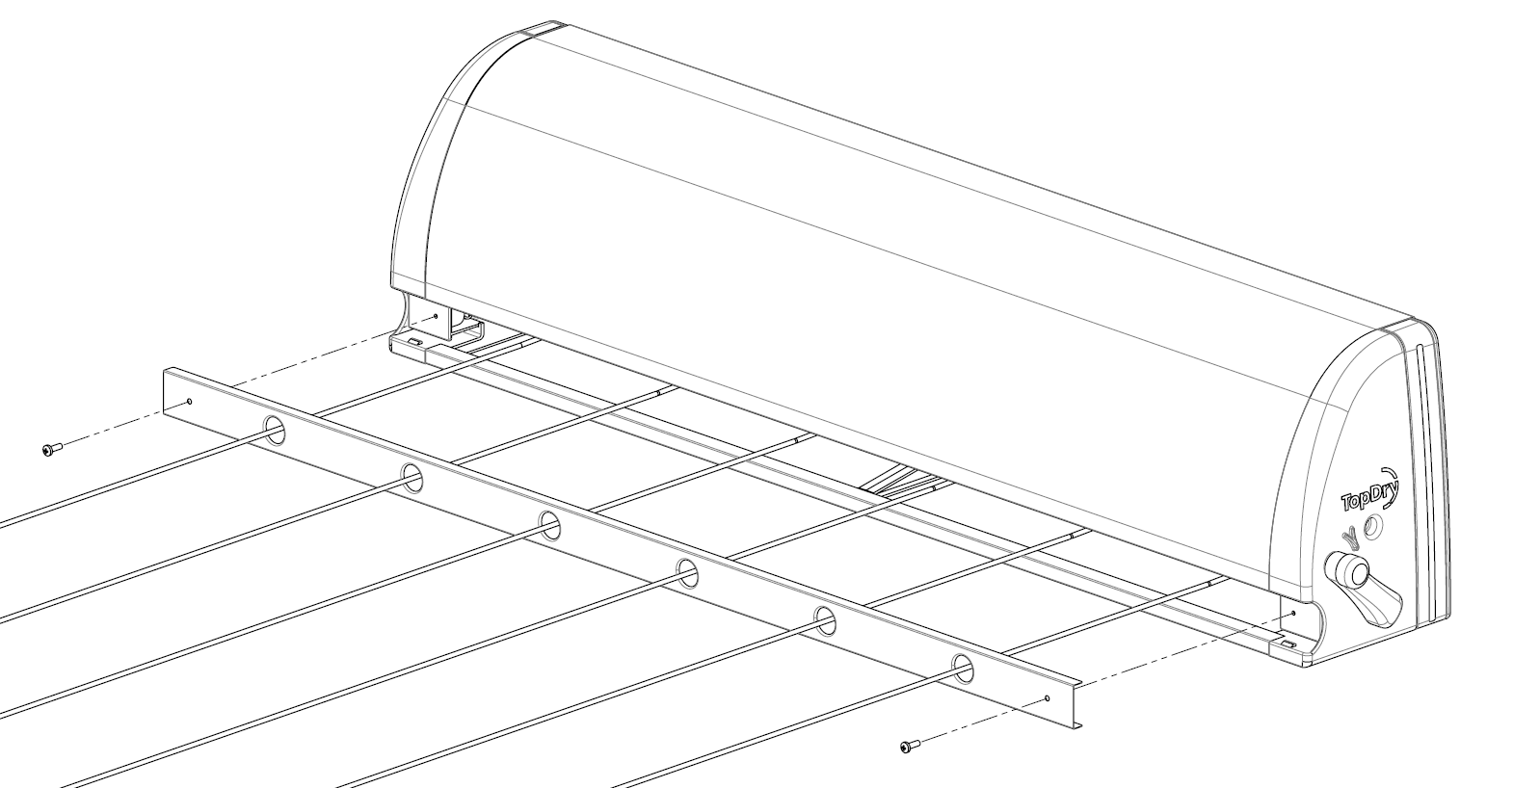
- Remove the two screws located behind the Front Bar and remove the Cover Plate.

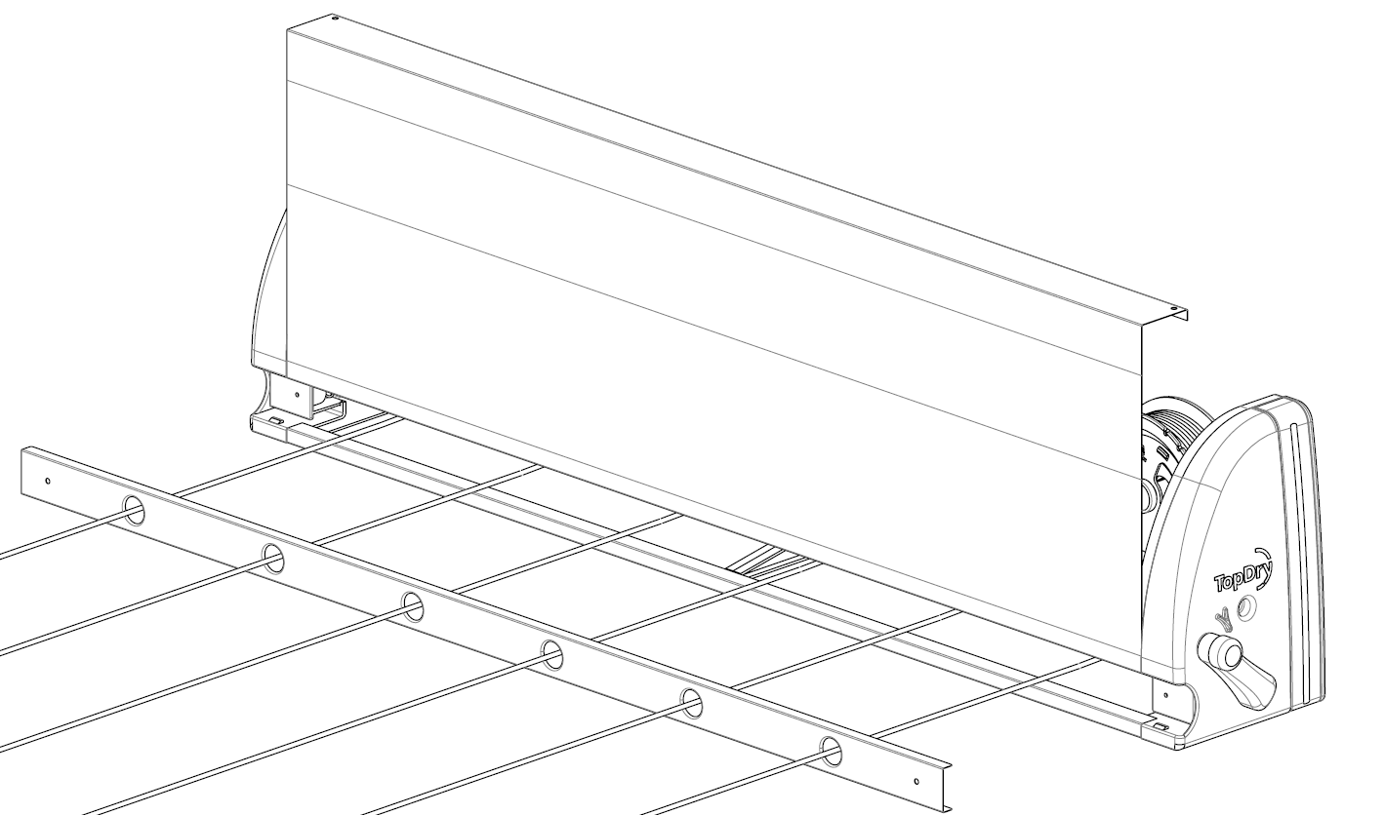
4
3
2
1
- Remove the upper panel by pusing the lower front edge inward and then pulling down to clear the central internal locking pin.
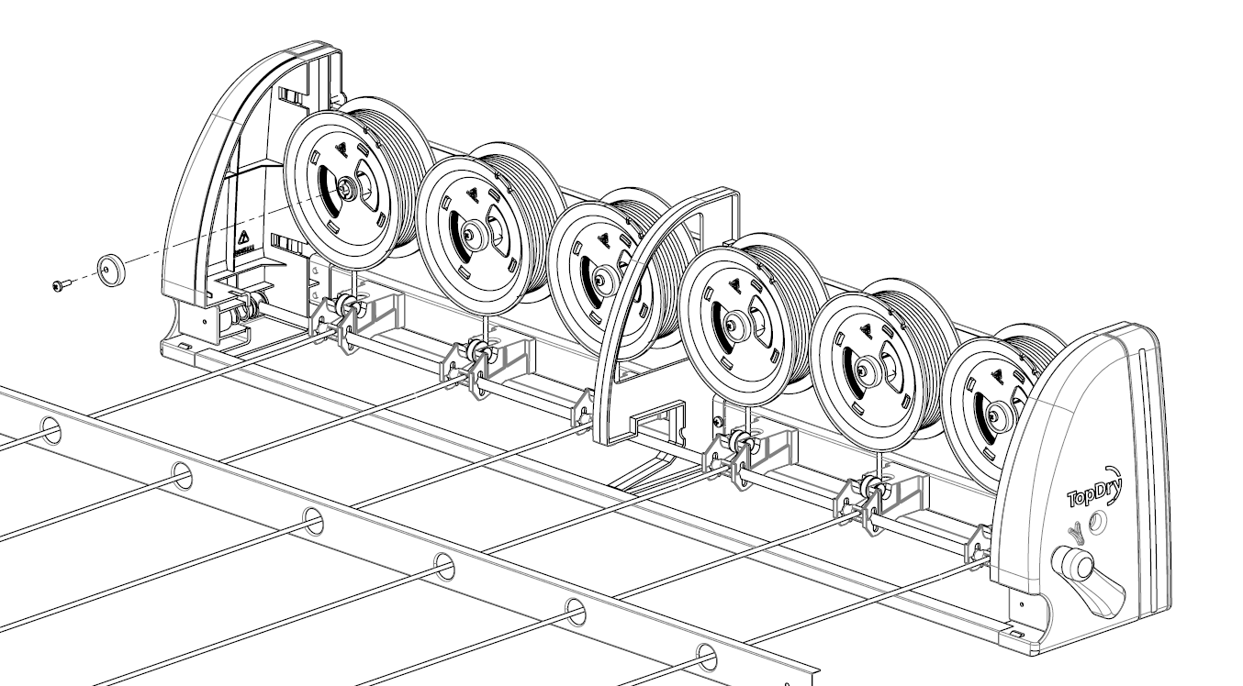
- Remove the cross head screw and locking cap from the Spool Assembly to be replaced

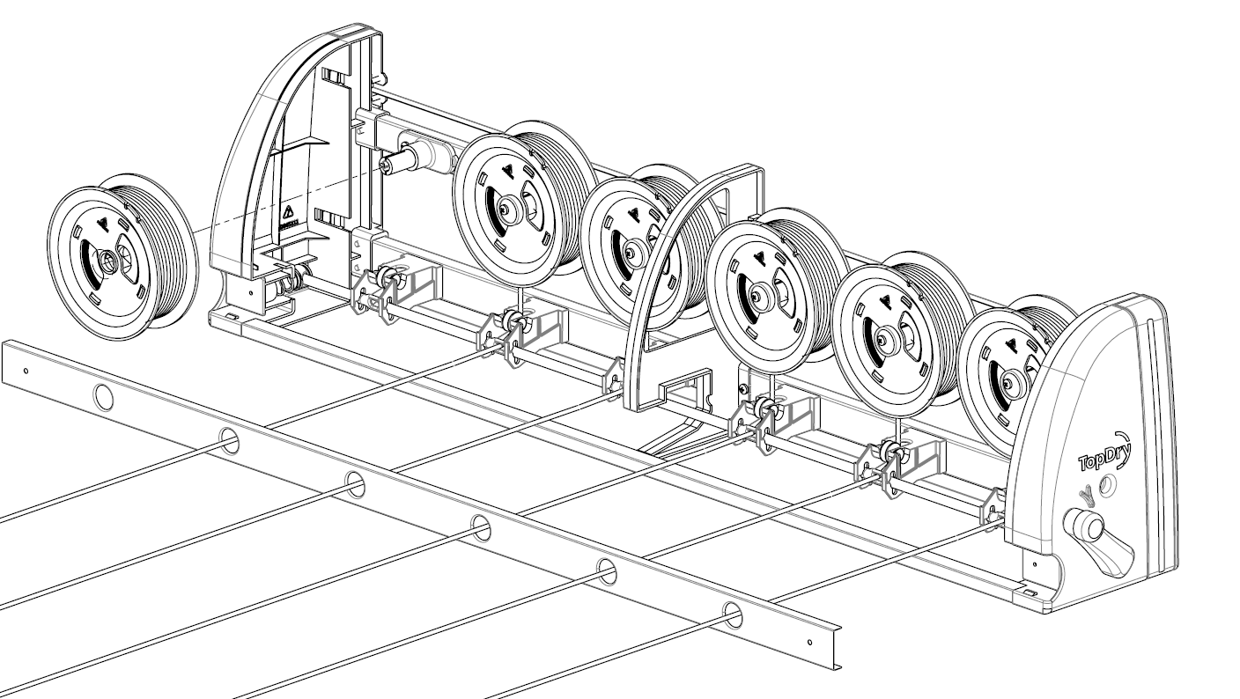
- Slide the spool forward off the shaft. Take care that the flat end of the internal spring slides off the shaft and unthread the line from the Locking Bar and Roller. Note: It may be necessary to relase the Locking Lever to unthread the line. Ensure the Front Bar is held securly while the lock is released to prevent it retracting back into the Cabinet.

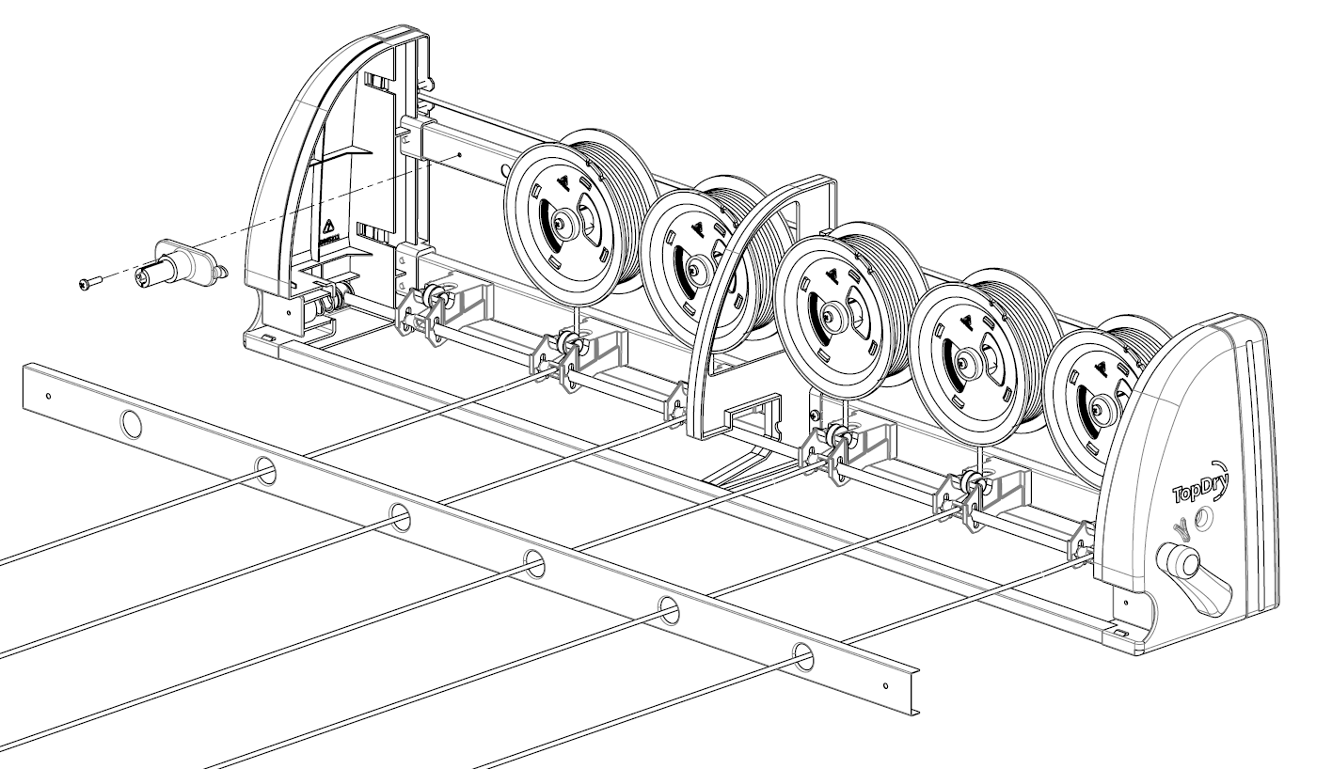
- Undo the cross head screw securing the Spool Shaft to the Cabinet Chassis. Once the screw is removed slide the Spool shaft to the left to disengage the locking tab.

Install the new Spool Assembly
- Locate the new Spool Shaft locking tab and secure with the cross head screw removed in Step 7

- Slide the new Spool Assembly over the Spool Shaft ensuring that the spring tab locates in the slot in the Spool Shaft.

- Reinstall the locking cap.

- Unwind line from the new Spool Assembly and thread it around the Roller and through the locking Bar. Use the other spools as a reference.
Note: It may be necessary to relase the Locking Lever to unthread the line. Ensure the Front Bar is held securly while the lock is released to prevent it retracting back into the Cabinet
- Ensuring the line length matches the other lines thread the line thought the Front Bar and secure to the tensioner.
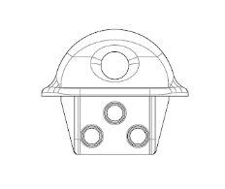  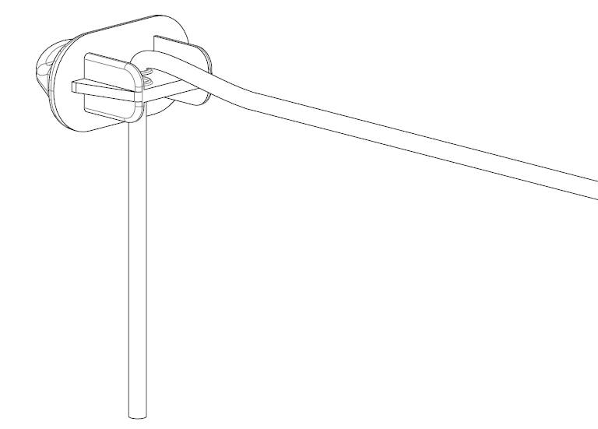 | 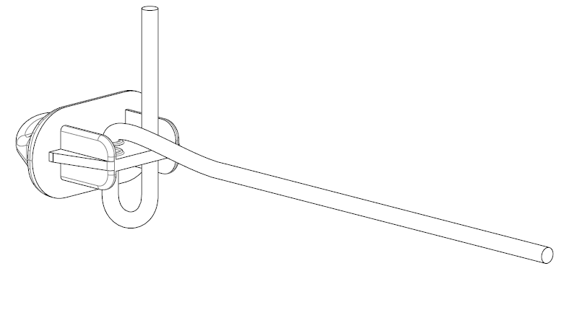
- Thread the line down through the Line Hook | - Loop the line up through the Line Hook
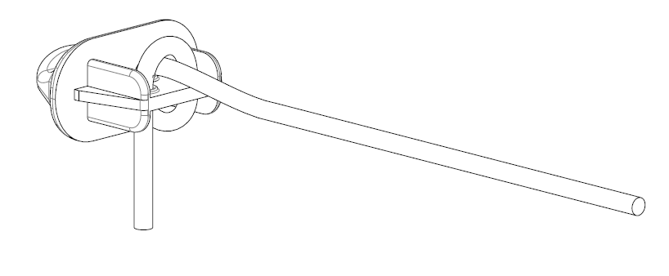 | 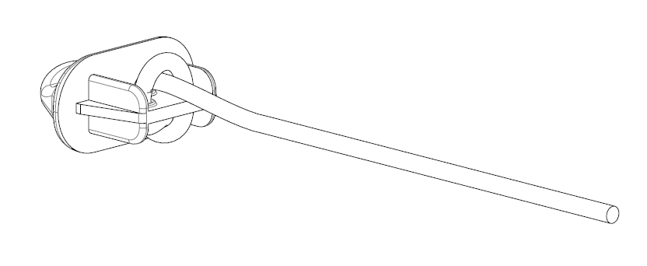
- Loop the the line over and down | - Insert the end of the line in the lower loop and tighten
- Reinstall the upper cover panel by pushing the lower edge back and then lifting up and pulling forward to locate on the locking pin..

- Roll the cover over the back of the Cabinet and secure with the two screws.

- Secure the Lower Cover Plate with the two screws.

- Release the Tension Lock and gently guide the Front Bar back to the cabinet. Remount the Cabinet to the origninal post or wall.

Sales Force National Pty Ltd (t/a Zenexus), ABN: 60 110 379 587. Phone: 1300 734 714 (AU), 0800 800 040 (NZ). E-mail: customerservice@zenexus.com.au(AU), customerservice@zenexus.co.nz (NZ). Website: www.zenexus.com.au

