TOPDRY Retracting Line – Grommet Installation Instructions
Parts List
AD05526 | Grommet | 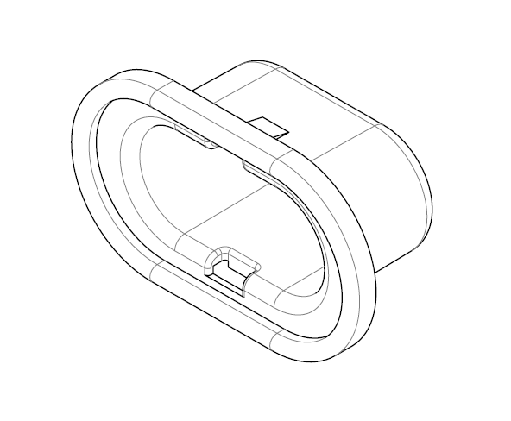

Remove the Grommet
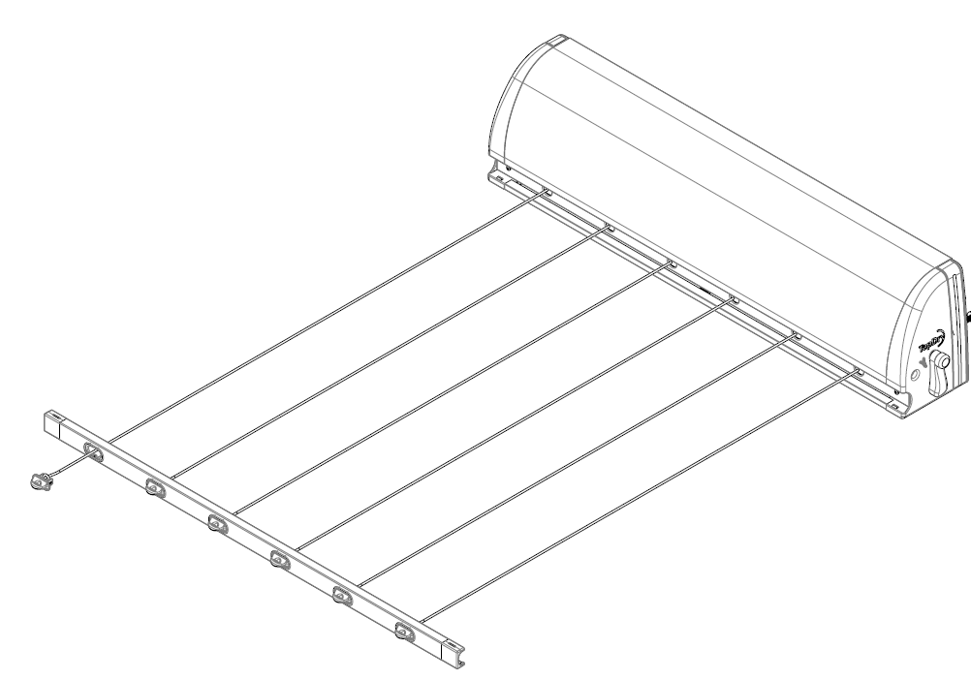
1
2
- Pull out the Front Bar at least 1 metre and pull out the line with the grommet to be changed an additional 100mm.  - Lock the line tensioner | - Use a flat bladed screw driver to carefully pry the grommet out of the Front Bar. Take care to not scratch the powdercoated finish.  - Untie the line from the Line Hook and thread the grommet of the line.

Fit the new Grommet
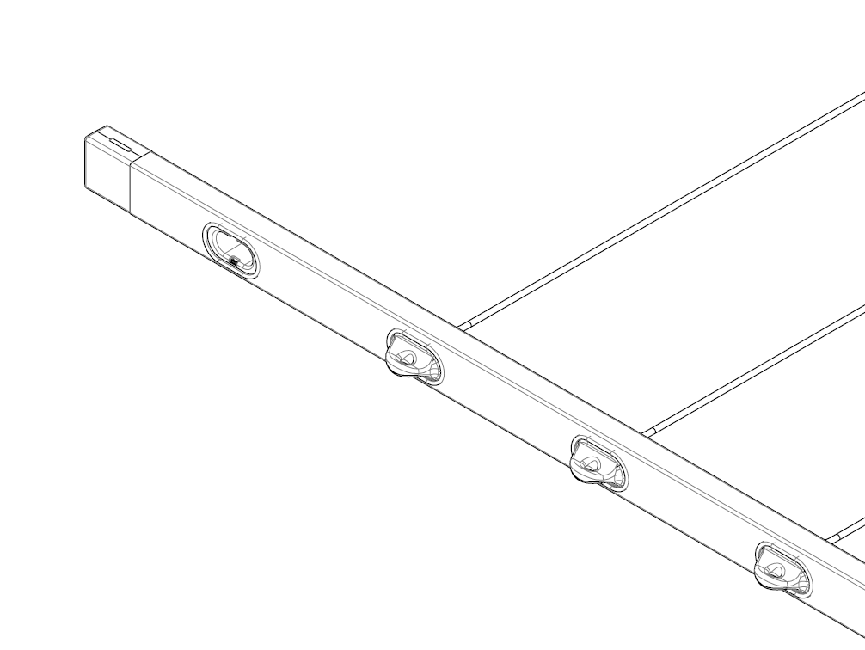 | 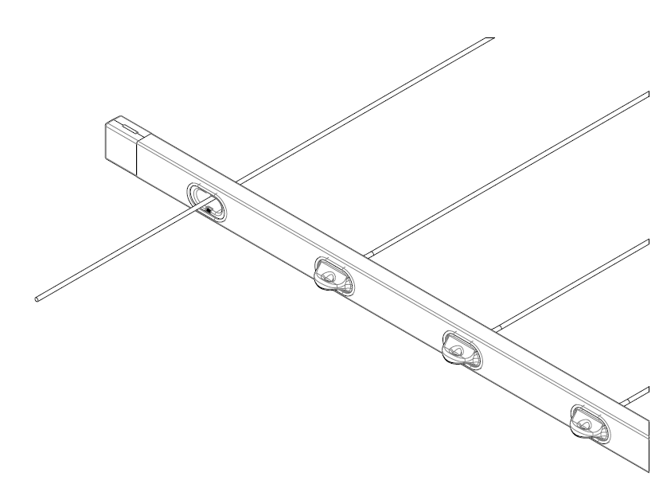
- Clip the new Grommet into the Front Bar | - Thread the line through the Grommet

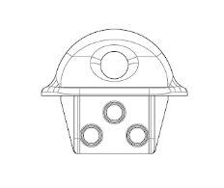  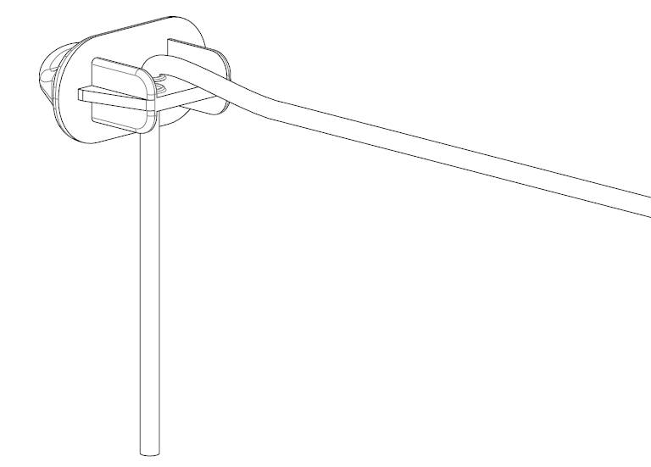 | 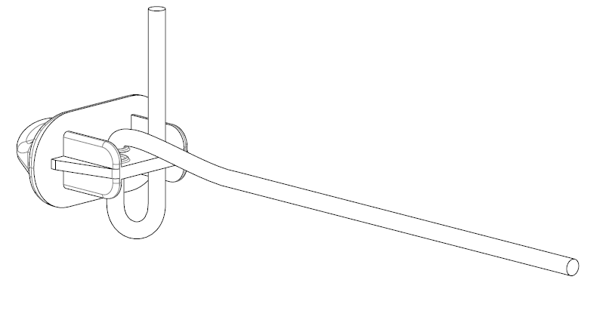
- Thread the line down through the Line Hook | - Loop the line up through the Line Hook
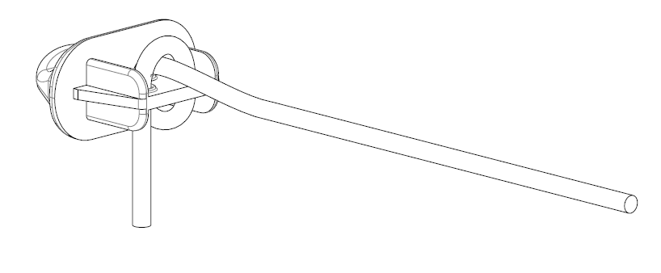 | 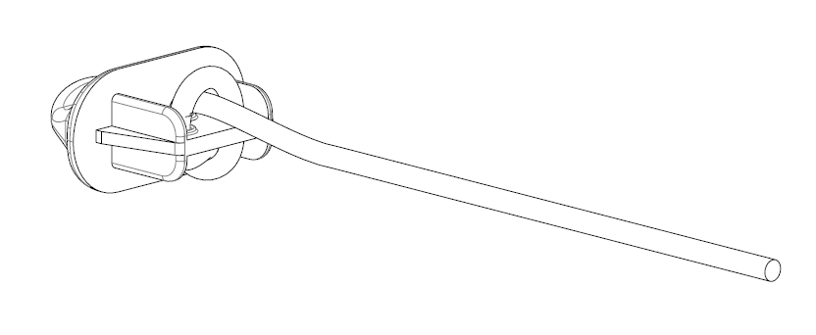
- Loop the the line over and down | - Insert the end of the line in the loop fromed in step 4 and tighten

Sales Force National Pty Ltd (t/a Zenexus), ABN: 60 110 379 587. Phone: 1300 734 714 (AU), 0800 800 040 (NZ). E-mail: customerservice@zenexus.com.au(AU), customerservice@zenexus.co.nz (NZ). Website: www.zenexus.com.au

